BN6SDM
Benelli BN302R ´17-

Kit for Right Side |  |  |  |  | Kit for Left Side
ID. | Description | Cat.No | Pcs |  |  | ID. | Description | Cat.No. | Pcs
1 | Steel adapter BN6-P | 724 | 1 |  |  | 1 | Steel adapter BN6-P | 723 | 1
2 | Bolt M10x50 | 996 | 1 |  |  | 2 | Bolt M10x50 | 996 | 1
3 | Allen Bolt M10x60 | 849 | 1 |  |  | 3 | Allen Bolt M10x50 | 849 | 1
4 | Bolt M6x20 | 1024 | 2 |  |  | 4 | Bolt M6x20 | 1024 | 2
5 | Dural. sleeve d=40mm | DV12 | 1 |  |  | 5 | Dural. sleeve d=40mm | DV12 | 1
6 | Washer M10 flat | 804 | 1 |  |  | 6 | Washer M10 flat | 804 | 1
7 | 3M tape |  | 2 |  |  | 7 | 3M tape |  | 2
8 | Dural. carrier SLD | 537/B | 1 |  |  | 8 | Dural. carrier SLD | 537/B | 1
9 | Washer M6 | 1023 | 2 |  |  | 9 | Washer M6 | 1023 | 2
10 | Spring M10 | 801 | 1 |  |  | 10 | Spring M10 | 801 | 1
Mounting Instructions:

- First, deinstall the original plastics on both sides.
- Mount the ID.1 steel adapter into the motorcycle frame using M10 ID.2 bolt, M10 ID.6 washer (don’t tighten yet). Protect places of possible impact with ID.7 3M tape as shown on attached pictures.
- Put the plastics back on and tighten the bolts now.
- Equip the ID.3 bolt with M10 ID.10 spring, ID.8 dural. carrier and ID.5 sleeve. Mount this assembly into the ID.1 steel adapter.
- Finally, use the ID.4 bolts and ID.9 washers to install the slider onto SLD carrier.
- Follow the same instructions on the other side.

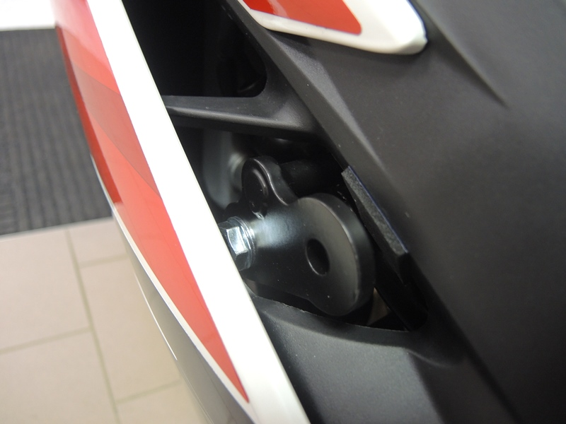
Note – We recommend using medium strength thread glue during assembly.

1
2
7

3
6

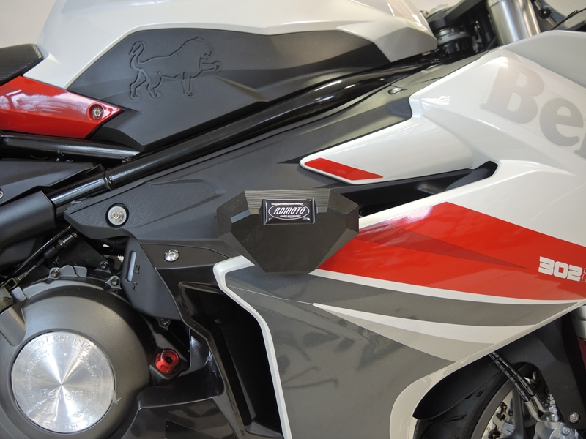

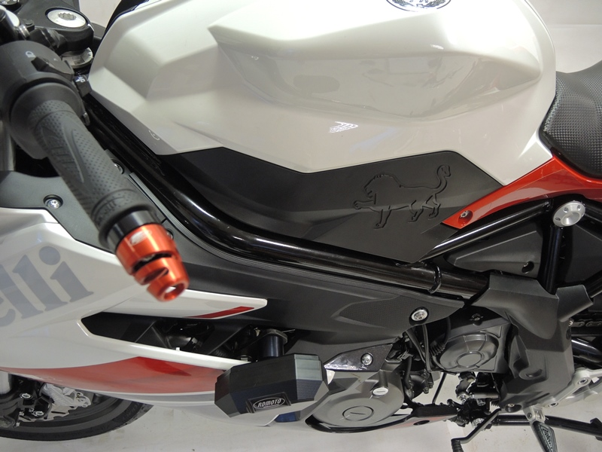
9
5
8
9,4

