BN6SD
Benelli BN302R ´17-

Mounting kit – Right side |  |  |  |  | Mounting kit – Left Side
ID. | Popis | Kat.č | Ks |  |  | ID. | Popis | Kat.č | Ks
1 | Steel adapter BN6-P | 724 | 1 |  |  | 1 | Steel adapter BN6-L | 723 | 1
2 | Bolt M10x50 | 996 | 1 |  |  | 2 | Bolt M10x50 | 996 | 1
3 | Bolt M10x60 hex | 849 | 1 |  |  | 3 | Bolt M10x60 hex | 849 | 1
4 | Molt M8x25 | 815 | 2 |  |  | 4 | Molt M8x25 | 815 | 2
5 | Dural. sleeve l=40mm | DV12 | 1 |  |  | 5 | Dural. sleeve l=40mm | DV12 | 1
6 | Flat washer M10 | 804 | 1 |  |  | 6 | Flat washer M10 | 804 | 1
7 | 3M tape |  | 2 |  |  | 7 | 3M tape |  | 2
8 | Dural. SLD rack | 537 | 1 |  |  | 8 | Dural. SLD rack | 537 | 1
9 | Washer M8 | 802 | 2 |  |  | 9 | Washer M8 | 802 | 2
10 | Spring washer M10 | 801 | 1 |  |  | 10 | Spring washer M10 | 801 | 1
Mounting instructions:

- Remove original plastics on both sides.
- Mount the steel adapter (ID1) in the motorcycle frame using M10 bolt (ID2) and M10 washer (ID6)- do not tighten the bolt, cover the possible places of contacts with 3M tape (ID 7) –see the photo.
- Put the plastics back on the motorcycle and tighten the bolts.
- Place the M10 spring washer (ID10), dural. rack (ID8) and sleeve (ID5) on the bolt (ID3). Install this assembly in the steel adapter (ID1)
- Mount the slider on the SLD rack using bolts (ID4) and mount the plate on it using bolts (ID9).
Use the same mounting procedure on the other side of the motorcycle.

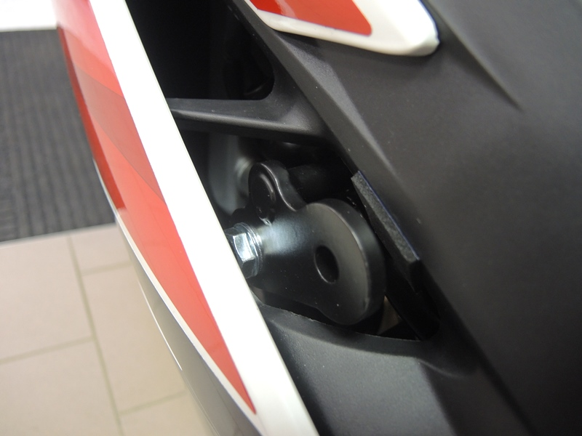
Warning - We recommend using medium strength thread glue during assembly.

1
2
7

3
6

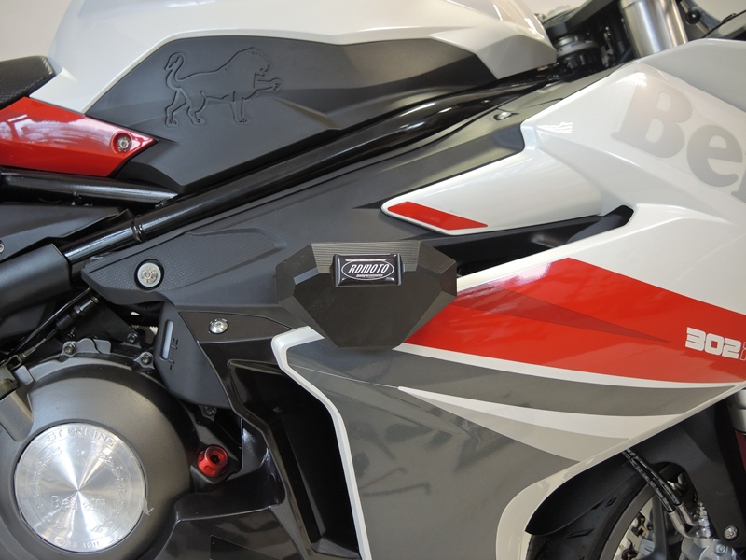

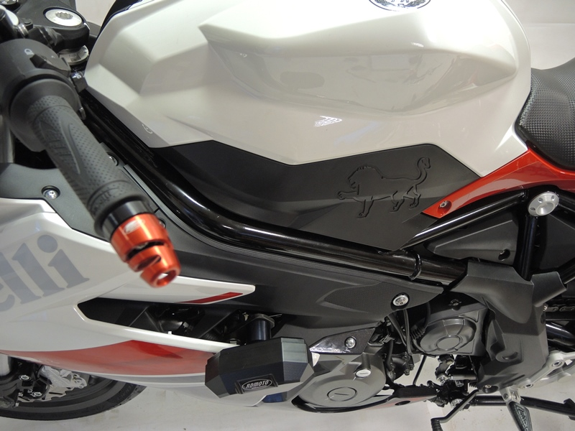
9
5
8
9,4

