BN6S
Benelli BN302R ´17-

Mounting kit – Right side |  |  |  |  | Mounting kit – Left Side
ID | Description | Cat.No | Pcs |  |  | ID | Description | Cat.No | Pcs
1 | Steel adapter BN6-P | 724 | 1 |  |  | 1 | Steel adapter BN6-L | 723 | 1
2 | Bolt M10x50 | 996 | 1 |  |  | 2 | Bolt M10x50 | 996 | 1
3 | Bolt M10x50 hex | 849 | 1 |  |  | 3 | Bolt M10x50 hex | 849 | 1
4 | Bolt M6x25 | 877 | 3 |  |  | 4 | Bolt M6x25 | 877 | 3
5 | Dural. sleeve l=10mm | DV1 | 1 |  |  | 5 | Dural. sleeve l=10mm | DV1 | 1
6 | Flat washer M10 | 804 | 1 |  |  | 6 | Flat washer M10 | 804 | 1
7 | 3M tape |  | 2 |  |  | 7 | 3M tape |  | 2
8 | Dural. adapter SL d=45 | DV352 | 1 |  |  | 8 | Dural. adapter SL l=45 | DV352 | 1
9 | Bolt M4x16 | 876 | 2 |  |  | 9 | Bolt M4x16 | 876 | 2
Mounting instructions:

- Remove original plastics on both sides.
- Mount the steel adapter (ID1) in the motorcycle frame using M10 bolt (ID2) and M10 washer (ID6) – do not tighten the bolt, cover the possible places of contacts with 3M tape (ID 7) –see the photo.
- Put the plastics back on the motorcycle and tighten the bolts
- Place the dural. Adapter (ID 8) and the sleeve (ID5) on the bolt (ID3). Install this assembly in the steel adapter (ID1).
- Mount the slider using bolts (ID4) and mount the plate on in using bolts (ID9)
- Use the same mounting procedure on the other side of the motorcycle.

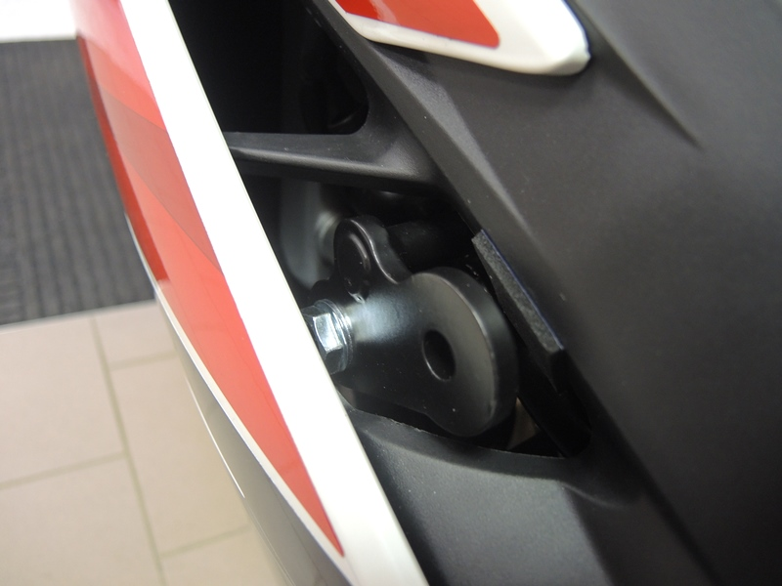
Warning - We recommend using medium strength thread glue during assembly.

1
2
7

3
6

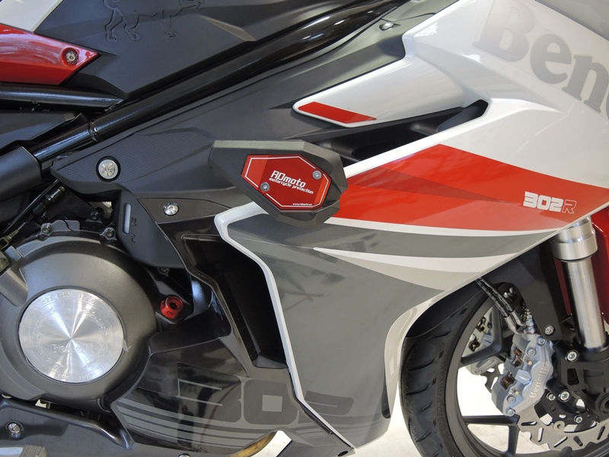

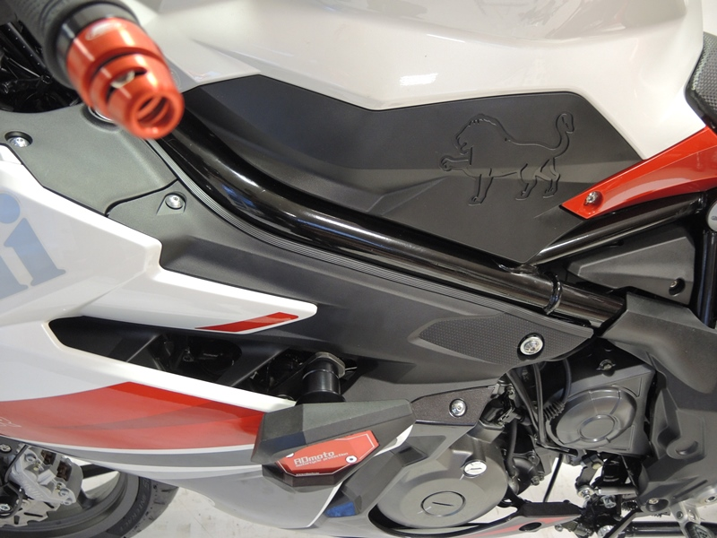
9
5
8

