BN6
Benelli BN302R ´17-

Mounting kit – Right side |  |  |  |  | Mounting kit – Left Side
ID | Description | Cat.No | Pcs |  |  | ID | Description | Cat.No | Pcs
1 | Steel adapter BN6-P | 724 | 1 |  |  | 1 | Steel adapter BN6-L | 723 | 1
2 | Bolt M10x50 | 996 | 1 |  |  | 2 | Bolt M10x50 | 996 | 1
3 | Bolt M10x60 hex | 850 | 1 |  |  | 3 | Bolt M10x60 hex | 850 | 1
4 | Steel insert | X1 | 1 |  |  | 4 | Steel insert | X1 | 1
5 | Dural. sleeve l=20mm | DV2 | 1 |  |  | 5 | Dural. sleeve l=20mm | DV2 | 1
6 | Flat washer M10 | 804 | 1 |  |  | 6 | Flat washer M10 | 804 | 1
7 | 3M tape |  | 2 |  |  | 7 | 3M tape |  | 2

Mounting instructions:

- Remove original plastics on both sides.
- Mount the steel adapter (ID1) in the motorcycle frame using M10 bolt (ID2) and M10 washer (ID6) – do not tighten the bolt, cover the possible places of contacts with 3M tape (ID 7) –see the photo.
- Put the plastics back on the motorcycle and tighten the bolts.
- Place the insert (ID4) in the protector, insert the M10 bolt (ID3), put the sleeve (ID5) on the bolt. Install this assembly in the steel adapter (ID1).
- Use the same mounting procedure on the other side of the motorcycle.

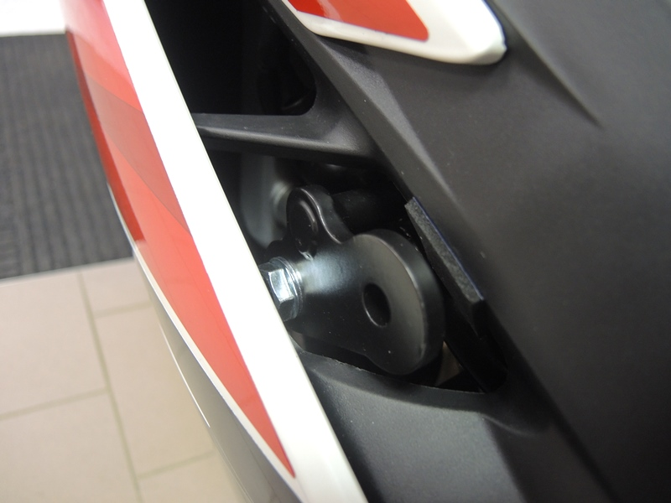
Warning - We recommend using medium strength thread glue during assembly.

1
2
5

3
6

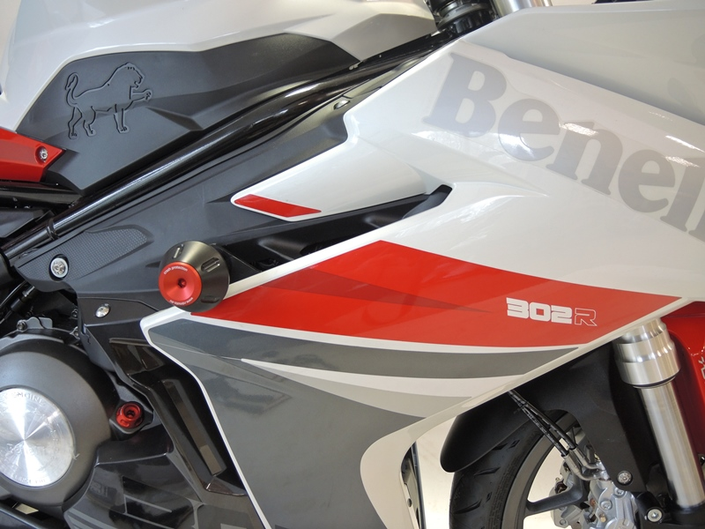

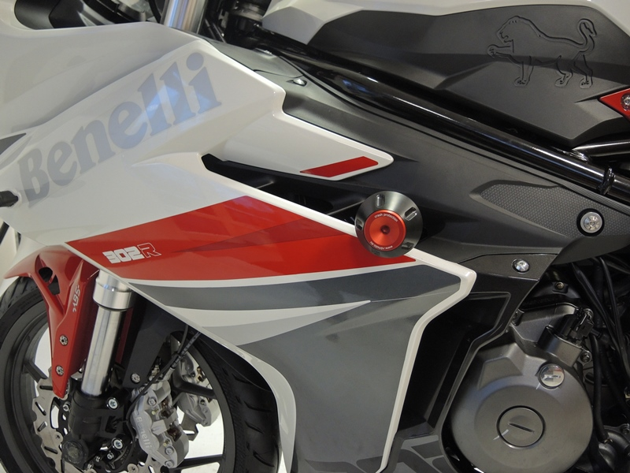
M páska

