BN7SDM
Benelli Leoncino Naked ´17-

Mounting Kit – Left Side: |  |  |  |  | Mounting Kit – Right Side
ID | Description | Cat.No | Pcs |  |  | ID | Description | Cat.No | Pcs
1 | Dural. sleeve for slider l=30mm | DV11 | 1 |  |  | 1 | Dural. sleeve for slider. d=60mm | DV14 | 1
2 | Bolt M10x160 | 979 | 1 |  |  | 2 | Bolt M10x160 | 979 | 1
3 | SLD adapter | 537/B | 1 |  |  | 3 | SLD adapter | 537/B | 1
4 | Bolt M6x20 | 1024 | 2 |  |  | 4 | Bolt M6x20 | 1024 | 2
5 | Washer M6 | 1023 | 2 |  |  | 5 | Washer M6 | 1023 | 2
6 | Flat washer M10 | 804 | 1 |  |  | 6 | Flat washer M10 | 804 | 1
7 | Self-locking nut M10 | 810 | 1 |  |  | 7 | Self -locking nut M10 | 810 | 1
8 | Spring washer M10 | 801 | 1 |  |  | 8 | Spring washer M10 | 801 | 1

Mounting instructions (both sides):

- Remove original bolts from the motorcycle frame.
- Insert dural. sleeve ID.1 into the frame. Slide the spring washer ID.8 and SLD adapter ID.3 onto the bolt ID.2.
- Mount this assembly to the motorcycle frame, tighten from the rear using the M10 ID.6 washer and nut ID.7.
- Mount the slider using bolts ID.4 and washers ID.5.
- Use the same assembly procedure on the other side of the frame.

Warning: We recommend using medium strength (blue) thread glue during assembly.
3
1
2
6
5
4
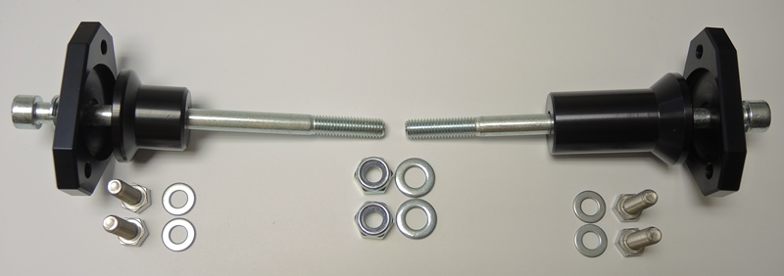
1
2
1
3
3
8
2
8

4
5
6
7
4
5

