BN7SD
Benelli Leoncino Naked ´17-

Mounting kit – Left Side |  |  |  |  | Mounting kit – Right Side
ID | Description | Cat.No | Pcs |  |  | ID | Description | Cat.No | Pcs
1 | Dural. sleeve for slider l=30mm | DV11 | 1 |  |  | 1 | Dural. sleeve for slider. d=60mm | DV14 | 1
2 | Bolt M10x160 | 979 | 1 |  |  | 2 | Bolt M10x160 | 979 | 1
3 | SLD adapter | 537 | 1 |  |  | 3 | SLD adapter | 537 | 1
4 | Bolt M8x25 | 815 | 2 |  |  | 4 | Bolt M8x25 | 815 | 2
5 | Washer M8 | 802 | 2 |  |  | 5 | Washer M8 | 802 | 2
6 | Flat washer M10 | 804 | 1 |  |  | 6 | Flat washer M10 | 804 | 1
7 | Self-locking nut M10 | 810 | 1 |  |  | 7 | Self -locking nut M10 | 810 | 1
8 | Spring washer M10 | 801 | 1 |  |  | 8 | Spring washer M10 | 801 | 1
Mounting instructions (both sides):

- Remove original bolts from the motorcycle frame.
- Insert dural. sleeve (ID1) into the frame. Slide the spring washer (ID8) and SLD adapter (ID3) onto the bolt (ID2).
- Mount this assembly to the motorcycle frame, tighten from the rear using the M10 (ID6) washer and nut (ID.7)
- Mount the slider using bolts (ID4) and washers (ID5.
- Use the same assembly procedure on the other side of the frame.

Warning - We recommend using medium strength thread glue during assembly.
3
1
2
6
5
4
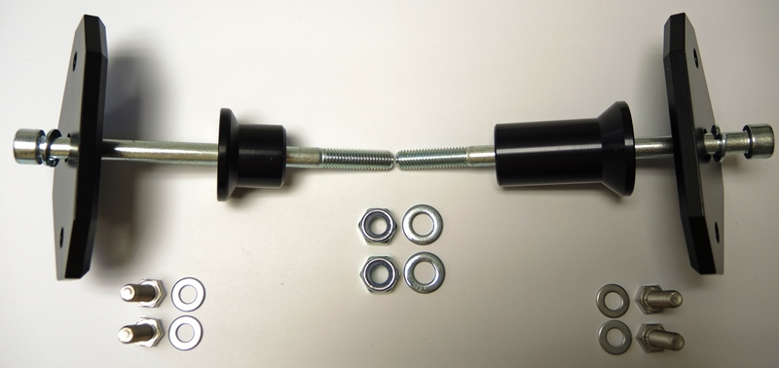

1
2
8
1
3
3
8
2

4
5
4
5

6
7

