BN7S
Benelli Leoncino Naked ´2017-
Mounting kit – Left Side |  |  |  |  | Mounting kit – Right side
ID | Description | Cat.No | Pcs |  |  | ID | Description | Cat.No | Pcs
1 | Slider adapter l=45 | DV-313 | 1 |  |  | 1 | Slider adapter l=45 | DV-313 | 1
2 | Bolt M6x25 | 877 | 3 |  |  | 2 | Bolt M6x25 | 877 | 3
3 | Bolt M4x16 | 876 | 2 |  |  | 3 | Bolt M4x16 | 876 | 2
4 | Bolt M10x160mm | 979 | 1 |  |  | 4 | Bolt M10x160mm | 979 | 1
5 | Dural. sleeve l=20mm | DV2 | 1 |  |  | 5 | Dural. Sleeve l=50mm | DV5 | 1
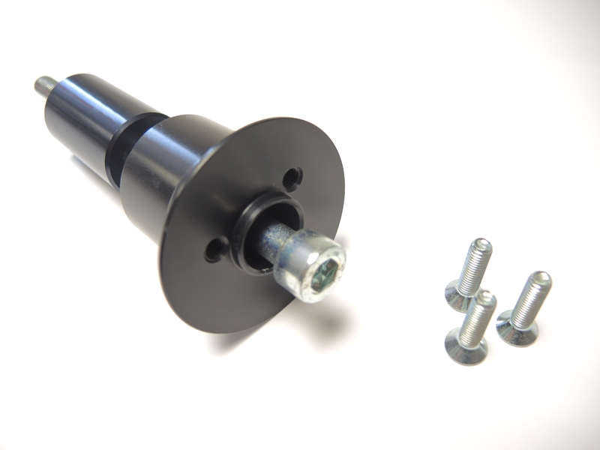

direction

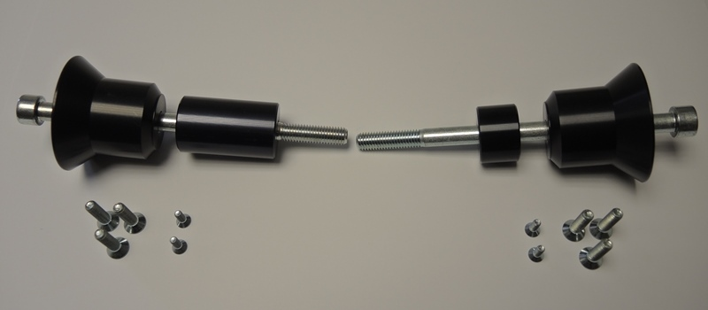

ID1
ID5
ID4

ID3
ID2

Mounting instructions (both sides):

- Remove original bolts – see the picture below.
- Prepare a kit for attaching the slider according to the photo above.
  - Insert the M10 bolt (ID4) into the slider adapter (ID1).
  - Slide the dural sleeve (ID5) onto the end of the screw.
  - Mount the entire kit on the motorcycle
- Mount the slider on the attached slider adapter using three M6 bolts (ID2).
- Mount the colored cover on the slider using two M4 bolts (ID3).

Warning - We recommend using medium strength thread glue during assembly.
