BN7
Benelli Leoncino Naked ´17-

Kit for right side |  |  |  |  | Kit for left side
ID. | Description | Cat. No. | Pcs. |  |  | ID. | Description | Cat. No. | Pcs.
1 | Dural. roller d=50mm | DV5 | 1 |  |  | 1 | Dural. roller d=20mm | DV2 | 1
2 | Steel housing | X1 | 1 |  |  | 2 | Steel housing | X1 | 1
3 | Bolt M10x170 | 935 | 1 |  |  | 3 | Bolt M10x170 | 935 | 1
4 | Washer M10 | 804 | 1 |  |  | 4 | Washer M10 | 804 | 1
5 | Safety Nut M10 | 810 | 1 |  |  | 5 | Safety nut M10 | 810 | 1

Mounting Instructions:

- Proceed with mounting of the crash protector into motorcycle frame as shown on attached pictures.
- Insert the ID.2 housing into the protector. Then, insert into it the ID.3 bolt and onto the bolt put the ID.1 roller. Take this assembly and mount it into the motorcycle frame.
- Now proceed with the same steps on the other side.

Note – We recommend using medium strength glue for threads of all screws during assembly.
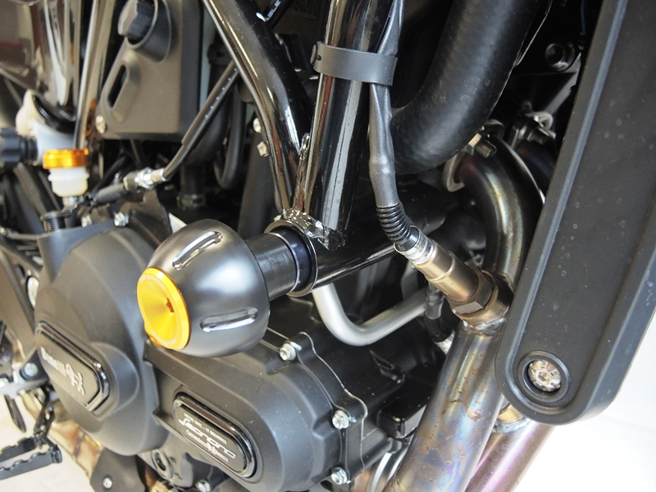

1

5

4

