BN8SDM
Benelli BN 125 2019-

Mounting kit – Left Side: Mounting kit – Right Side:
ID | Description | Cat.No | Pcs
1 | Lock nut M10 | 810 | 1
2 | Dural. sleeve l=20mm | 1308 | 1
3 | Dural. SLDM adapter | 537/B | 1
4 | Bolt M6x20 | 1024 | 2
5 | Washer M6 | 1023 | 2
6 | Dural. sleeve l=30mm | DV11 | 1
7 | Rod 10x375x1,25 |  | 1
ID | Description | Cat.No | Pcs
1 | Lock nut M10 | 810 | 1
2 | Dural. sleeve l=20mm | 1308 | 1
3 | Dural. SLDM adapter | 537/B | 1
4 | Bolt M6x20 | 1024 | 2
5 | Washer M6 | 1023 | 2
6 | Dural. sleeve l=30mm | DV11 | 1

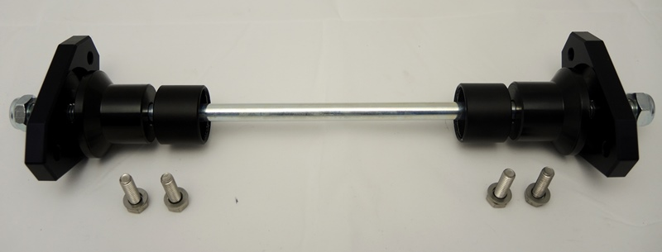
1
1
2
2
3
3
7
4
4
4
5
6
6
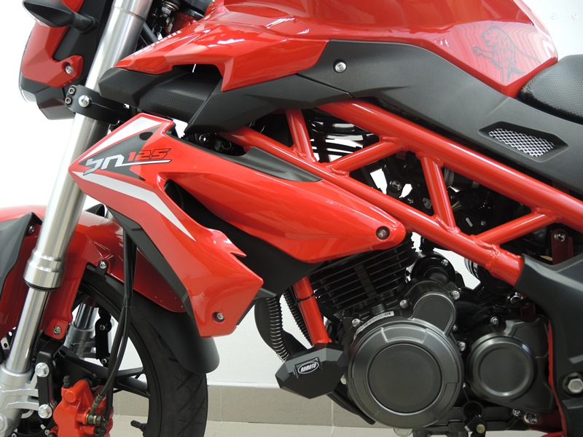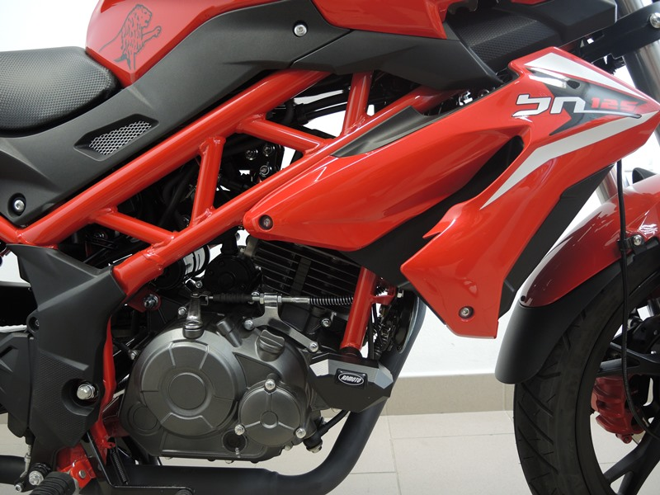
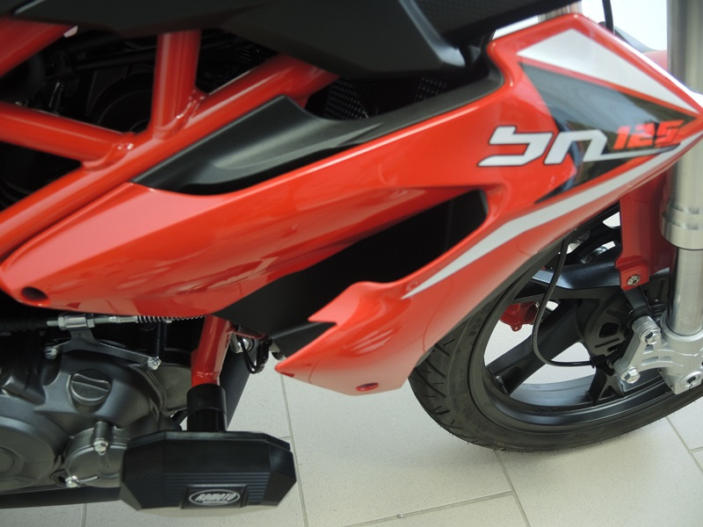

Mounting instructions (both sides):

- Remove original bolt M10 from the motorcycle frame.
- Insert the rod M10 ID.7 through the frame.
- Place dural. sleeves ID.2 + ID.6 and SLDM adapter ID.3 on both sides of the rod. Fasten the assembly with the nut M10 ID.1 (see photo).
- Finally, fasten the slider using bolt M8 ID.4. and washers M8 ID.5.

Warning - We recommend using medium strength (blue) thread glue during assembly
