BN8SD
Benelli BN 125 2019-

Mounting kit – Left Side: Mounting kit – Right Side

ID | Description | Cat.No | Pcs
1 | Lock nut M10 | 810 | 1
2 | Dural. sleeve l=20mm | 1308 | 1
3 | Dural. SLD adapter | 537 | 1
4 | Bolt M8x25 | 815 | 2
5 | Washer M8 | 876 | 2
6 | Dural. sleeve l=30mm | DV11 | 1
7 | Rod 10x375x1,25 |  | 1
ID | Description | Cat.No | Pcs
1 | Lock nut M10 | 810 | 1
2 | Dural. sleeve l=20mm | 1308 | 1
3 | Dural. SLD adapter | 537 | 1
4 | Bolt M8x25 | 815 | 2
5 | Washer M8 | 876 | 2
6 | Dural. sleeve d=30mm | DV11 | 1

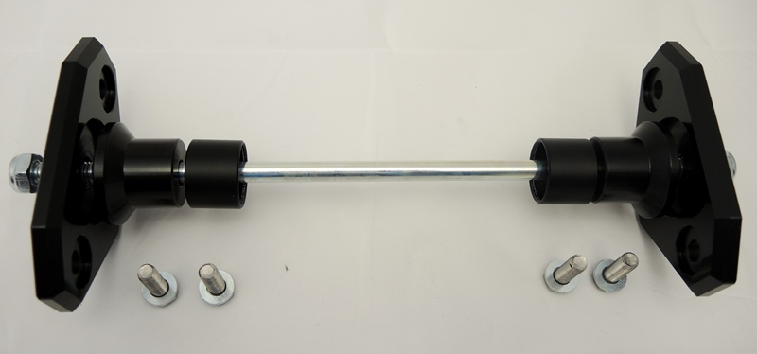
1
1
2
2
3
3
7
4
4
4
5
6
6
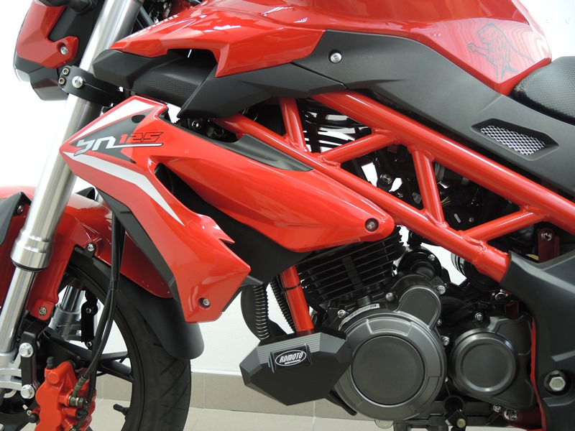
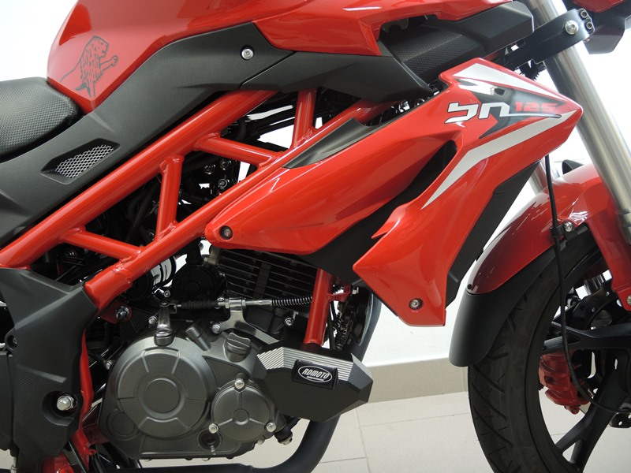

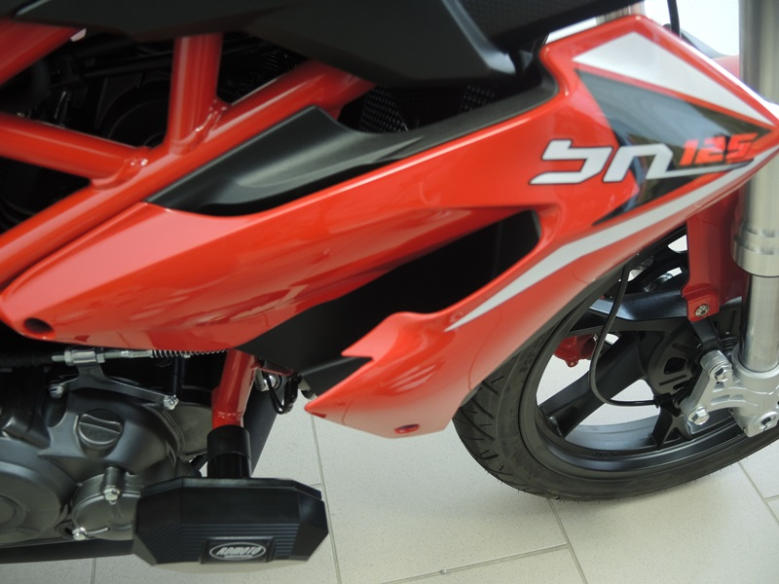

Mounting instructions (both sides):

- Remove original bolt M10 from the motorcycle frame.
- Insert the M10 (ID7) rod through the frame.
- Place dural. sleeves (ID2 + ID 6) and SLD adapter (ID3) on both sides of the rod. Fasten the assembly with the nut M10 ID.1 (see photo).
- Finally, fasten the slider using M8 bolt (ID4) and M8 washers (ID5).

Warning - We recommend using medium strength thread glue during assembly.
