BN8S
Benelli BN 125 2019-

Mounting Kit Left Side: Mounting Kit Right Side:
ID | Popis | Kat.č. | Ks
1 | Steel Nut M10 | X11 | 1
2 | Dural. Roller d=20mm | 1308 | 1
3 | Dural. Adapter SL | 317 | 1
4 | Bolt M6x25 | 877 | 3
5 | Bolt M4x16 | 876 | 2
6 | Rod 10x375x1,25 |  | 1
ID | Popis | Kat.č. | Ks
1 | Steel Nut M10 | X11 | 1
2 | Dural. Roller d=20mm | 1308 | 1
3 | Dural. Adapter SL | 317 | 1
4 | Bolt M6x25 | 877 | 3
5 | Bolt M4x16 | 876 | 2

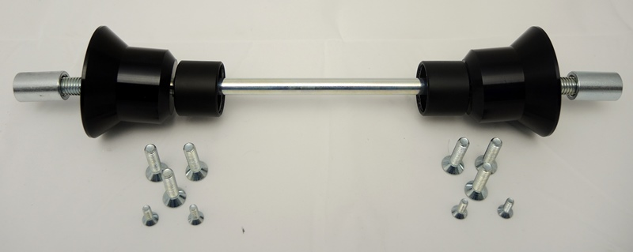
1
1
2
2
3
3
6
4
4
4
5

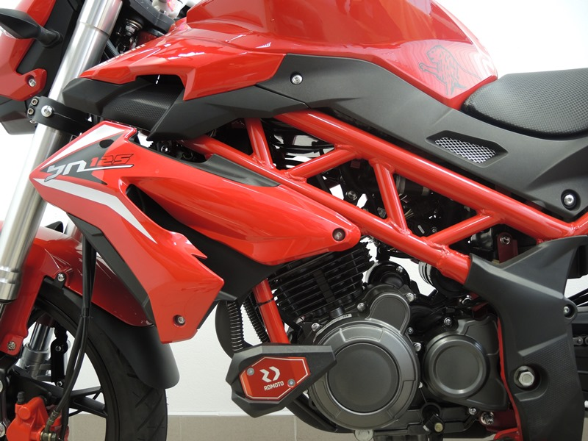
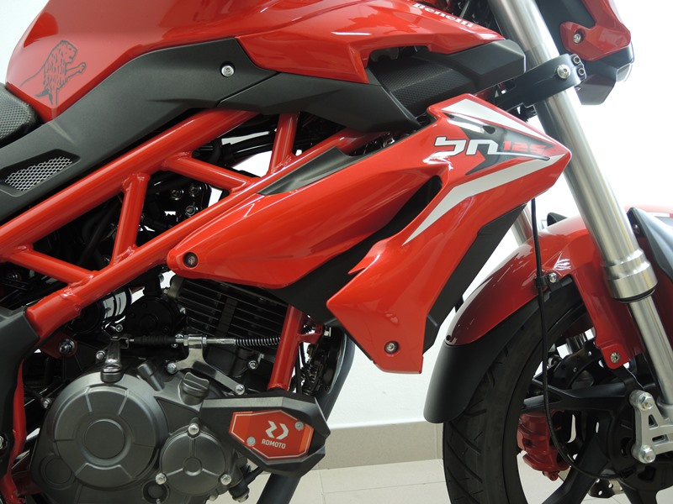

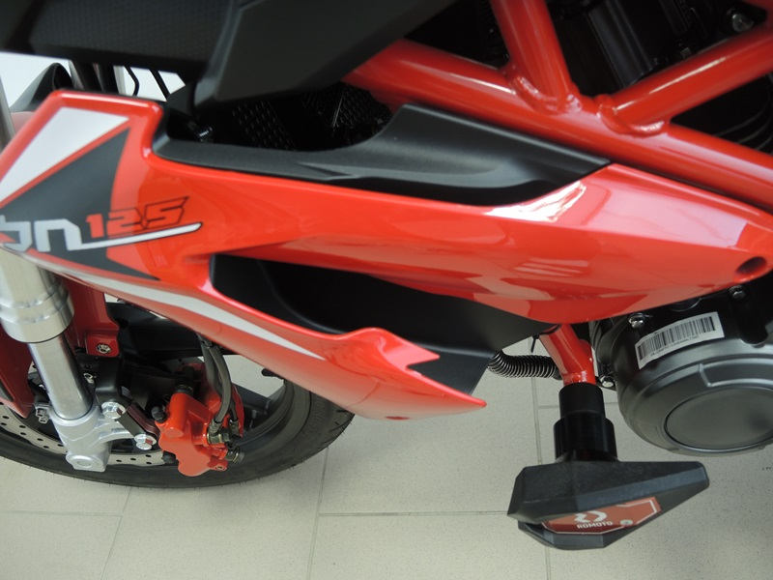

Mounting Instructions:
- Dismount original M10 rod from motorcycle frame.
- Take the ID.6 M10 rod and push it through the frame.
- Fit ID.2 roller and ID.3 SL Adapter onto the rod from both sides. Secure them in place using ID.1 steel nut.
- Use bolts M6 ID.4 to attach the slider and ID.5 M4 bolt to attach the small plate (cover).

Note: We recommend using medium strenght thread glue during assembly (blue color).
