BN8
Benelli BN 125 2019-

Mounting Kit Left Side: Mounting Kit Right Side:
ID | Description | Cat. No. | Pcs
1 | Steel Insert M10 | X1 | 1
2 | Dural. Roller d=20mm | 1308 | 1
3 | Steel Nut M10 | X11 | 1
4 | Rod 10x400x1,25 |  | 1
ID | Description | Cat.No. | Pcs
1 | Steel Insert M10 | X1 | 1
2 | Dural. Roller d=20mm | 1308 | 1
3 | Steel Nut M10 | X11 | 1

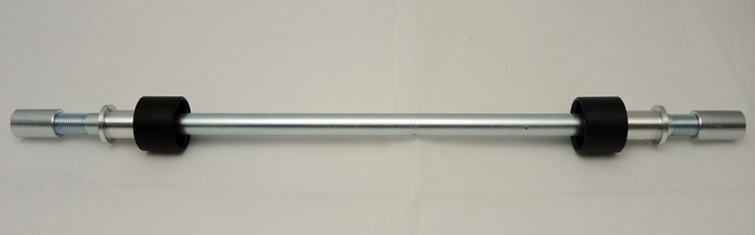
1
1
2
2
3
3
4

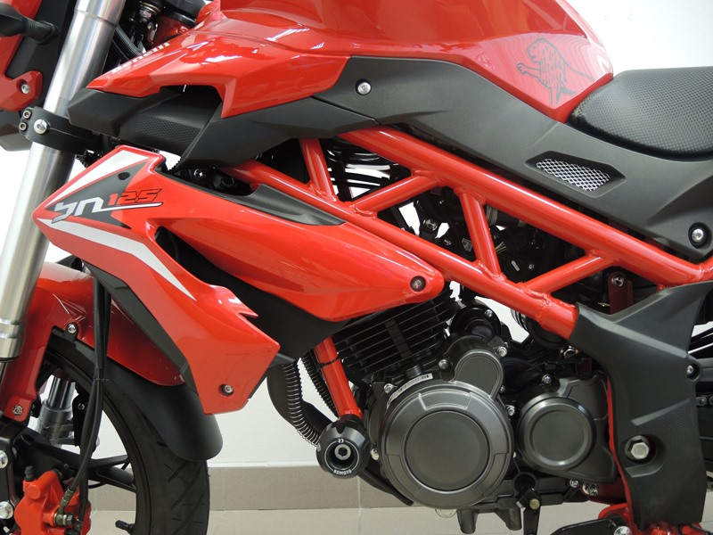
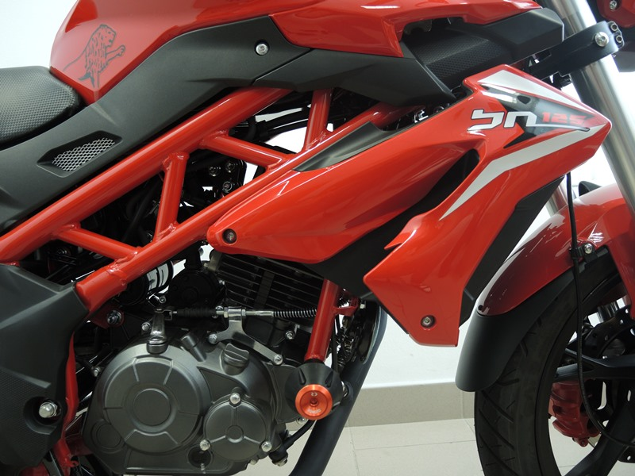

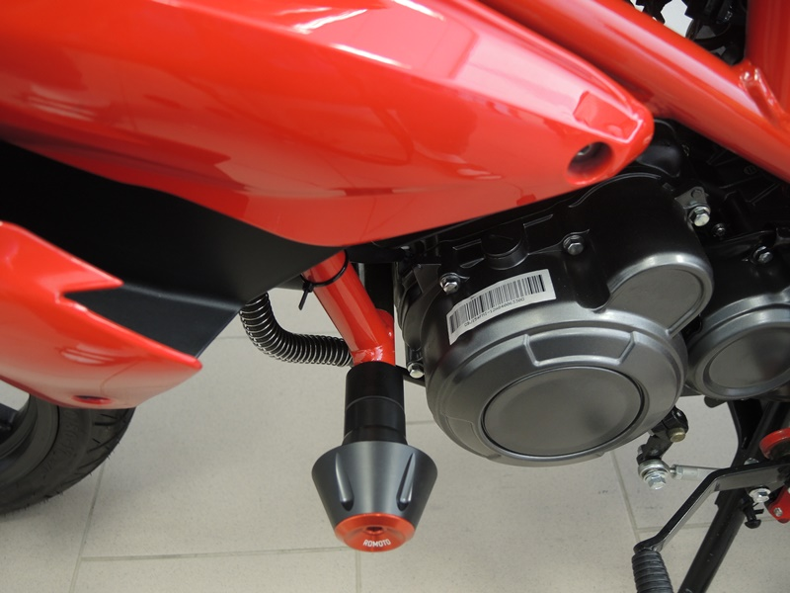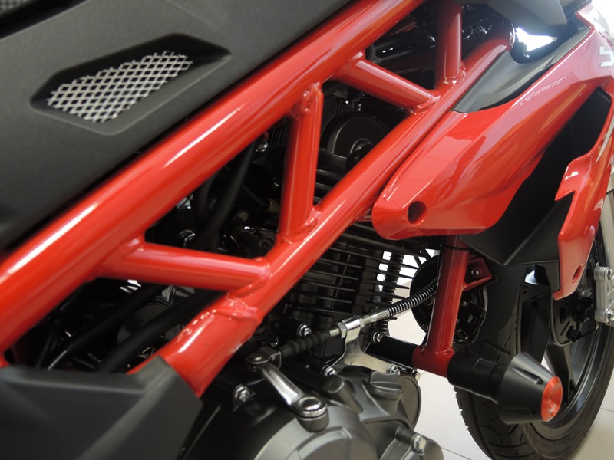

Mounting Instructions:
- Dismount original M10 rod from motorcycle frame.
- Take the ID.4 M10 rod and push it through the frame.
- Put on ID.2 roller from both sides of the rod.
- Push the ID.1 steel insert into protector and mount this assembly onto the rod from both sides.
- As a last step, attach the full set using M10 ID.3 steel nut.

Note: We recommend using medium strenght thread glue during assembly (blue color).

