BN9S

**Benelli 752S 2019-**

|  |  |  |  |  |  |  |  |  |  |  |
| --- | --- | --- | --- | --- | --- | --- | --- | --- | --- | --- |
| **Kit for the Left Side** | | | | | **Kit for the Right Side** | | | | | |
|  |  |  |  |  | |  |  |  |  |  |
| ID | Description | Cat.no. | Pcs |  | | ID | Description | Cat.no. | Pcs |  |
| 1 | Bolt M10x160mm | 979 | 1 |  | | 1 | Bolt M10x30mm | 882 | 1 |  |
| 2 | Dural. sleeve length 40,5mm | 1327 | 1 |  | | 2 | Dural. bolt length 20mm | 447 | 1 |  |
| 3 | Safety Nut M10 | 810 | 1 |  | | 3 | Dural. Sleeve length 39mm | 1328 | 1 |  |
| 4 | Bolt M6x25mm | 877 | 3 |  | | 4 | Bolt M6x25mm | 877 | 3 |  |
| 5 | Bolt M4x12mm | 876 | 2 |  | | 5 | Bolt M4x12mm | 876 | 2 |  |
| 6 | Dural. adapter | 317 | 1 |  | | 6 | Dural. adapter | 317 | 1 |  |
|  |  |  |  |  | |  |  |  |  | |

**Mounting Kit:**

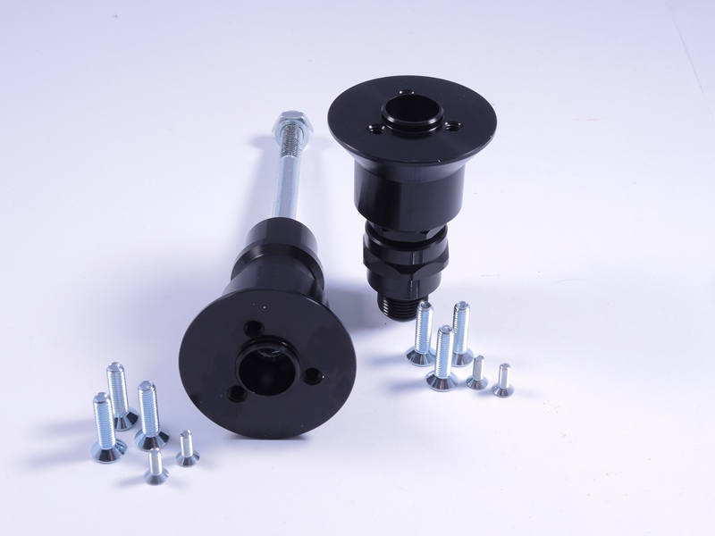

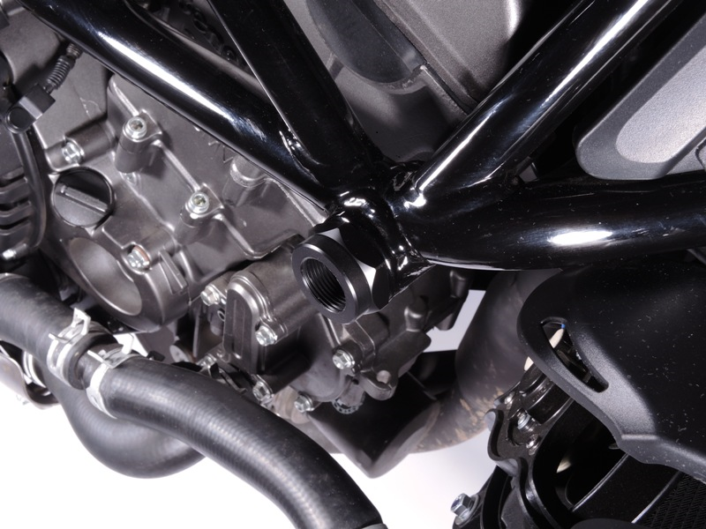

**Mounting of the Right Side:**

1. Remove the original plastic cover in the motorcycle frame
2. Mount the Dural. sleeve (ID. 3) into the frame
3. Install the Dural. bolt (ID. 2) into the Dural. sleeve
4. Insert the bolt into the Dural. adapter (ID 6) and mount it in the thread in the Dural. bolt
5. Put on a slider and fasten the bolts (ID.4)
6. Insert the cover into the slider and fasten the bolts (ID 5)

**Note – we recommend using medium strength (blue) safety glue on the threads of all screws.**

**Mounting of the Left Side:**

1. Remove the original plastic cover in the motorcycle frame
2. Insert Dural. sleeve (ID 2) into the frame
3. Insert the Bolt (ID 1) into the dural. adapter (ID 6) and pass it through the motorcycle frame. Secure with the nut (ID 3) from the back.
4. Put on a slider and fasten the bolts (ID.4)
5. Insert the cover into the slider and fasten the bolts (ID 5)

**Note – we recommend using medium strength (blue) safety glue on the threads of all screws.**

