BN9

**Benelli 752S 2019-**

|  |  |  |  |  |  |  |  |  |  |  |
| --- | --- | --- | --- | --- | --- | --- | --- | --- | --- | --- |
| **Kit for the Left Side** | | | | | **Kit for the Right Side** | | | | | |
|  |  |  |  |  | |  |  |  |  |  |
| ID | Description | Cat.no. | Pcs |  | | ID | Description | Cat.no. | Pcs |  |
| 1 | AL insert M10 | X1 | 1 |  | | 1 | AL insert M10 | X1 | 1 |  |
| 2 | Bolt M10x170mm | 935 | 1 |  | | 2 | Bolt M10x40mm | 854 | 1 |  |
| 3 | Dural. sleeve length 40,5mm | 1327 | 1 |  | | 3 | Dural. Bolt length 20mm | 447 | 1 |  |
| 4 | Safety Nut M10 | 810 | 1 |  | | 4 | Dural. Sleeve length 39mm | 1328 | 1 |  |
|  |  |  |  |  | |  |  |  |  | |

**Mounting Kit:**

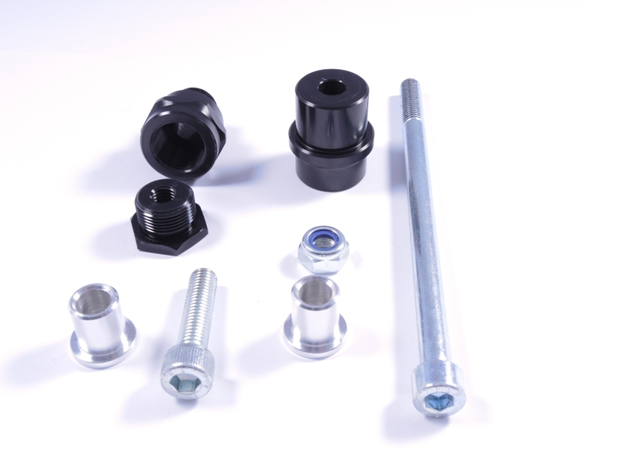

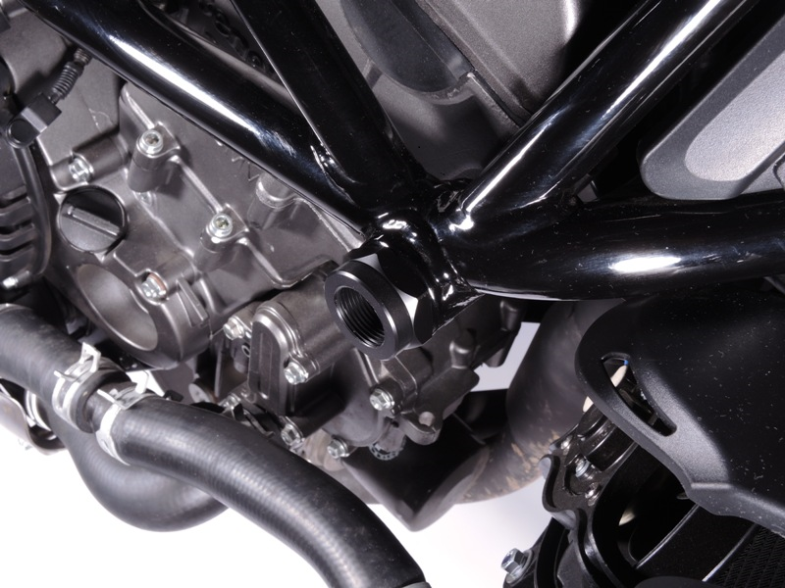

**Mounting of the Right Side:**

1. Remove the original plastic cover in the motorcycle frame
2. Mount the Dural. sleeve (ID. 4) into the frame
3. Install the Dural. bolt (ID. 3) into the Dural. sleeve
4. Insert the AL insert (ID. 1) into the crash protector
5. Insert the bolt (ID. 2) through the crash protector and mount it to the Dural. bolt on the motorcycle

**Note – we recommend using medium strength (blue) safety glue on the threads of all screws.**

**Mounting of the Left Side:**

1. Remove the original plastic cover in the motorcycle frame
2. Insert Dural. sleeve (ID 3) into the frame
3. Insert AL insert (ID 1) in the crash protector
4. Insert the bolt (ID 2) through the crash protector and mount it to the motorcycle frame, secure with a nut from the back

**Note – we recommend using medium strength (blue) safety glue on the threads of all screws.**

