C1SDM
Cagiva Raptor 1000

Kit for left side:

ID | Description | Cat.no | Qty
1 | Adapter SLDM | 537/B | 1
2 | Bolt M12x130x1,25mm | 1027 | 1
3 | Dural.cylinder d=85mm | 1192 | 1
4 | Dural adapter pro SLD | DV149 | 1
5 | Bolt M6x20 | 1024 | 2
6 | Washer M6 | 1023 | 2

Kit for right side:

ID | Description | Cat.no | Qty
1 | Adapter SLDM | 537/B | 1
2 | Bolt M12x150x1,25mm | 984 | 1
3 | Dural.cylinder d=105mm | 1193 | 1
4 | Dural adapter for SLD | DV149 | 1
5 | Bolt M6x20 | 1024 | 2
6 | Washer M6 | 1023 | 2

Instruction to assembly:
- Take out original bolt from frame on the left side.
- Insert bolt M12 (ID2) through the adapter ID1, dural. cylinder ID4 and ID3.
- Mount this kit into the frame of motorcycle.
- Fit slider on the adapter using two bolts M8 (ID5) and nuts M8 (ID6).

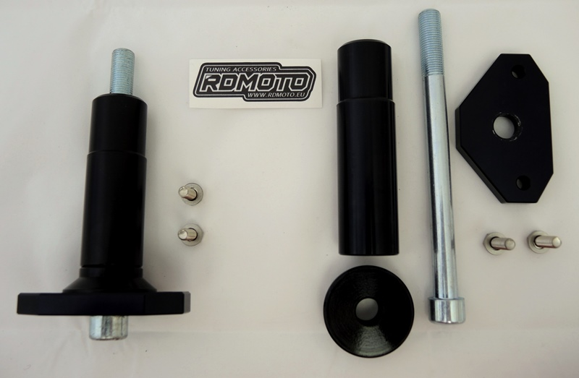
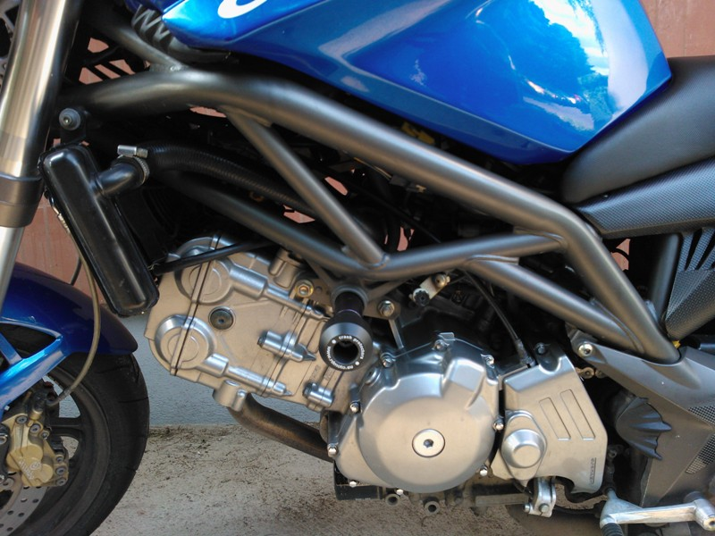
We recommend to use the glue on all threads (medium strong).

