C1S
Cagiva Raptor 1000

Kit for left side:

ID | Description | Cat.no | Qty
1 | Adapter SL d=20mm | DV1137 | 1
2 | Bolt M12x125x1,25mm | 952 | 1
3 | Dural.cylinder d=85mm | 1192 | 1
4 | Bolt M6x25 | 877 | 3
5 | Bolt M4x16 | 876 | 2

Kit for right side:

ID | Description | Cat.no | Qty
1 | Adapter SL d=20mm | DV1137 | 1
2 | Bolt M12x150x1,25mm | 984 | 1
3 | Dural.cylinder d=105mm | 1193 | 1
4 | Bolt M6x25 | 877 | 3
5 | Bolt M4x16 | 876 | 2

Instruction to assembly:
- Take out original bolt from frame on the left side.
- Insert bolt M12 (ID2) through the adapter ID1, dural. cylinder ID3.
- Mount this kit into the frame of motorcycle.
- Fit slider on the adapter using three bolts M6 (ID4) and plate two bolts M4 (ID5).

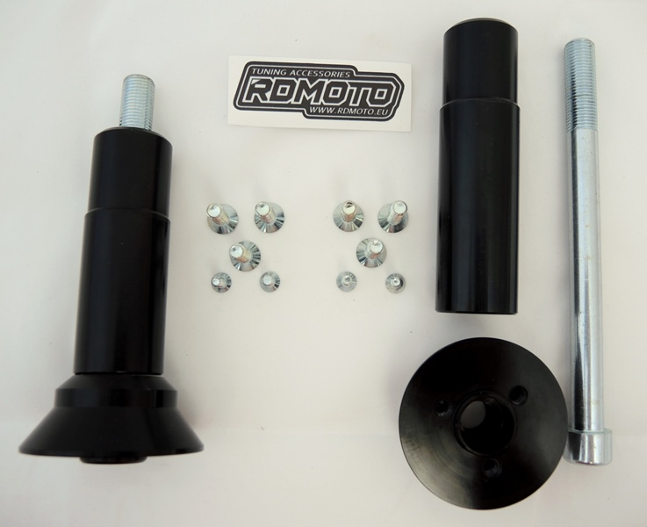
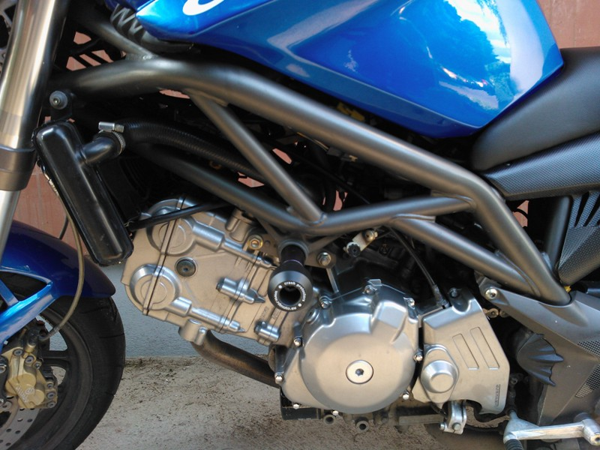
We recommend to use the glue on all threads (medium strong).

