C1
Cagiva Raptor 1000

Kit for left side:

ID | Description | Cat.no | Qty
2 | Steel box | X2 | 1
3 | Bolt M12x130x1,25mm | 1027 | 1
4 | Dural.cylinder d=85mm | 1192 | 1
Kit for right side:

ID | Description | Cat.no | Qty
2 | Steel box | X2 | 1
3 | Bolt M12x150x1,25mm | 984 | 1
4 | Dural.cylinder d=105mm | 1193 | 1

Instruction to assembly:
- Take out original bolt from frame on the left side.
- Into the frame insert dural.cylinder ID.4 (short).
- Insert steel box into the bobbins ID.2. Use the bolt ID.3 and mount this set on the bike.
- Instruction for right side is same.

We recommend use the glue of all threads (medium strong).
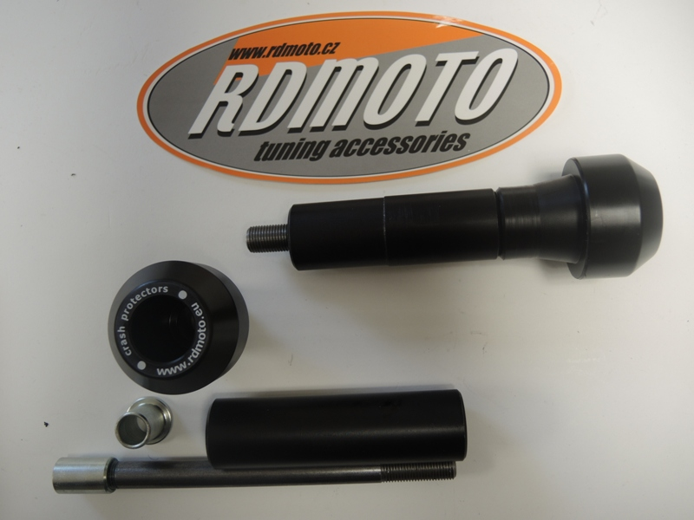
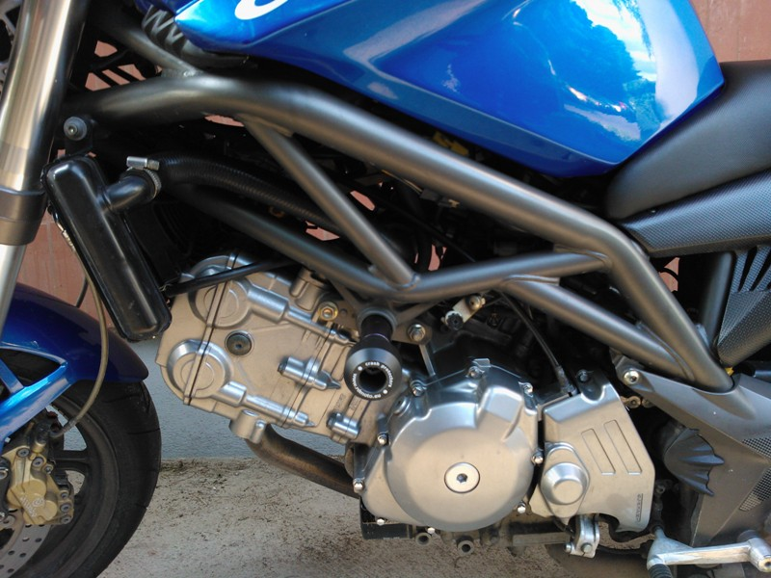
1
4
3
1
2
3
4

