D1(10)
Ducati Monster 600/750/900 (-2000)

ID. | Description | Cat.no | pcs
1 | Connecting rod M10x(1,25)x395x30x30 |  | 1
2 | Steel insert | X1 | 2
3 | Special nut M10x1,25 | X11 | 2
4 | Dural roller d=46mm | 25 | 1
5 | Dural roller d=48mm | 26 | 1

- Remove orignial screws.
- Prepare set same as on the picture below.
  - Insert steel (ID1) rod into frame.
  - On both sides put dural rollers(ID4 and ID5) on the rod.
  - Don’t forget to place steel insert into protector.
  - Tighten it with special nut (ID3).

front
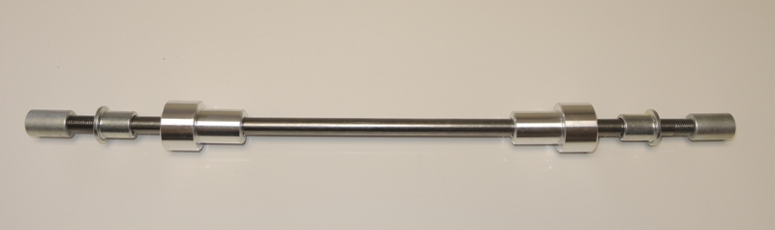
3
2
3
5
4
2
1

