D10S
Ducati Hyperstrada 821 (13-)
Mounting Kit For Left Side |  |  |  |  |  |  |  |  | Mounting Kit For Right Side
ID | Description |  | Cat.no. |  | Pcs. |  |  |  | ID | Description |  | Cat.no. |  | Pcs.
1 | Slider Adapter d = 45mm |  | DV314 |  | 1 |  |  |  | 1 | Slider Adapter d = 45mm |  | DV314 |  | 1
2 | Steel Nut M12 |  | X12 |  | 1 |  |  |  | 2 | Steel Nut M12 |  | X12 |  | 1
3 | Dural. Roller – 85mm |  | 1199 |  | 1 |  |  |  | 3 | Dural. Roller – 85mm |  | 1199 |  | 1
4 | Bolt M6x25 |  | 877 |  | 3 |  |  |  | 4 | Bolt M6x25 |  | 877 |  | 3
5 | Bolt M4x16 |  | 876 |  | 2 |  |  |  | 5 | Bolt M4x16 |  | 876 |  | 2
6 | Steel Rod 12(1,25)x445x30x30 |  | - |  | 1 |  |  |  | - | - |  | - |  | -

Instructions:
- First, take off the original bolts from frame.
- Push the ID.9 Steel Rod through the frame.
- Fit the ID.3 Dural. Rollers onto both ends of this rod.
- Now fit the ID.1 Slider Adapters after the Dural. Rollers. Tighten this assembly with M12, ID.2 nuts.
- Now fit the slider onto the slider adapter using three M6, ID.4 Bolts.
- Finally, attach the colored cover cap with two M4, ID.5 Bolts.
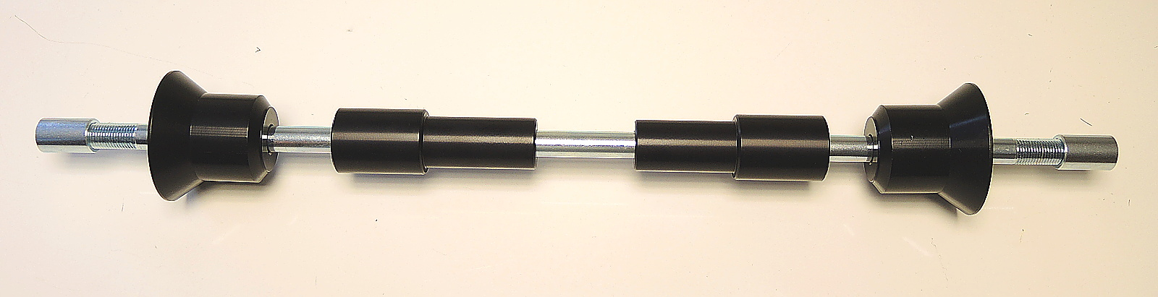
ID3
ID1
ID6
ID2

