D12S
Ducati S4R/S4RS/S4
Kit for the left side |  |  |  |  |  |  |  |  | Kit for the right side
ID | Description |  | Cat.no. |  | Pcs |  |  |  | ID | Description |  | Cat.no. |  | pcs
1 | Slider adapter |  | DV314 |  | 1 |  |  |  | 1 | Slider adapter |  | DV314 |  | 1
2 | Steel nut M12 |  | X12 |  | 1 |  |  |  | 2 | Steel nut M12 |  | X12 |  | 1
3 | Dural. cylinder – 86mm |  | 1161 |  | 1 |  |  |  | 3 | Dural. cylinder – 66mm |  | 1162 |  | 1
4 | Bolt M6x25 |  | 877 |  | 3 |  |  |  | 4 | Bolt M6x25 |  | 877 |  | 3
5 | Bolt M4x16 |  | 876 |  | 2 |  |  |  | 5 | Bolt M4x16 |  | 876 |  | 2
6 | Steel rod 12(1,25)x435x30x30 |  | - |  | 1 |  |  |  | - | - |  | - |  | -

Instructions:
- Remove original bolt from frame of motorcycle.
- Insert steel rod (ID6) trough the frame.
- Mount cylinders (ID3 – longer on the left side) on both ends of steel rod.
- Mount slider adapters (ID1) behind cylinders and thighten this set using steel nut (ID2).
- Fit slider on the slider adapter using three bolts M6 (ID4).
- Fit coloured cover using two M4 bolts (ID5).

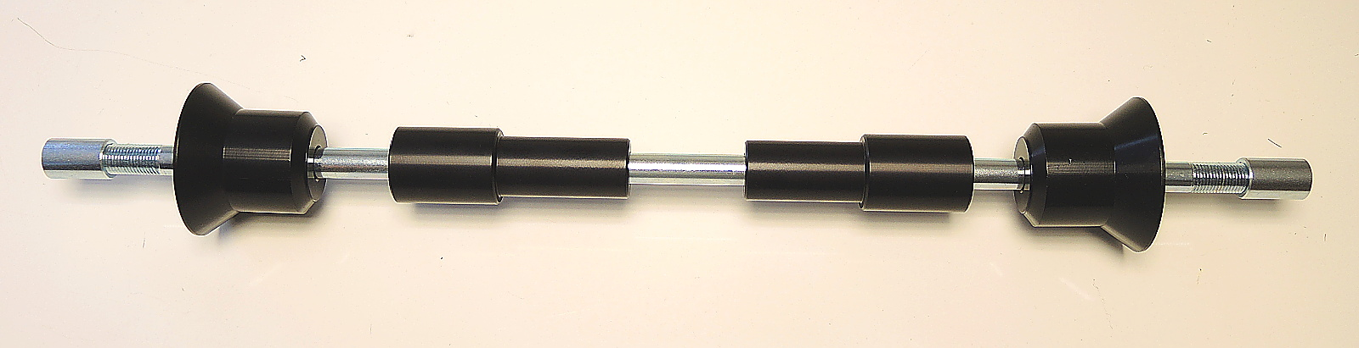
ID3
ID1
ID6
ID2

