D15S

Ducati Hyperstrada 939 2016-

Ducati Hypermotard 821/939 2016-

Mounting kit – Left Side: Mounting kit – Right Side:
ID | Popis | Kat.č. | Ks
1 | Moto adapter | 1200+314 | 1
2 | Bolt M6x25 | 877 | 3
3 | Bolt M4x16 | 876 | 2
4 | Steel nut M12 | X12 | 1
5 | Stainless steel rob M12x455x1,25mm |  | 1
ID | Popis | Kat.č. | Ks
1 | Moto adapter | 1199+  314 | 1
2 | Bolt M6x25 | 877 | 3
3 | Bolt M4x16 | 876 | 2
4 | Steel nut M12 | X12 | 1

To connect the left and right sides, the mounting kit includes a stainless steel rod (N1) with a length of 365 mm, M12x1.25 mm threads at both ends.

Montáž :
1. Remove original M12 bolt from the frame.
2. Insert the stainless steel rod (ID5) into the frame.
3. Slide the adapters (ID1) from the left and right sides.
4. Fasten the adapters using M12 nut (ID4).
5. Install the slider using the bolts (ID2).
6. Insert the cover into the slider and fasten using bolts (ID3)

Warning - We recommend using medium strength thread glue during assembly.

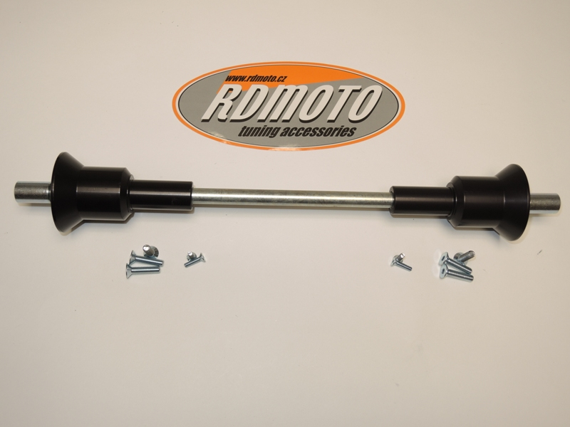
4
4
1
1
5
2
3
3
2
