D15
Ducati Hyperstrada 939/Hypermotard 821/939 2016-

Left side mounting kit: Right side mounting kit:
ID | Description | Cat.no | pcs
1 | Steel nut M12 | X12/X2 | 1
2 | Dural. Cylinder–90mm | 1200 | 1
 | Stainless steel rod M12(1,25)x435x30x30xmm |  | 1
ID | Description | Cat.no. | pcs
1 | Steel nut M12 | X12/X2 | 1
2 | Dural. Cylinder–85mm | 1199 | 1

Instructions:

- Remove original bolt M12.
- Push stainless steel rod M12x435x1,25mm trough the frame of motorcycle.
- Put dural. Cylinders (ID2) on both ends of stainless steel rod. Longer cylinder is on the left side.
- protectors and put this kit on both ends of stainless steel rod.
- Tighten both protectors using steel nut M12 (ID1).

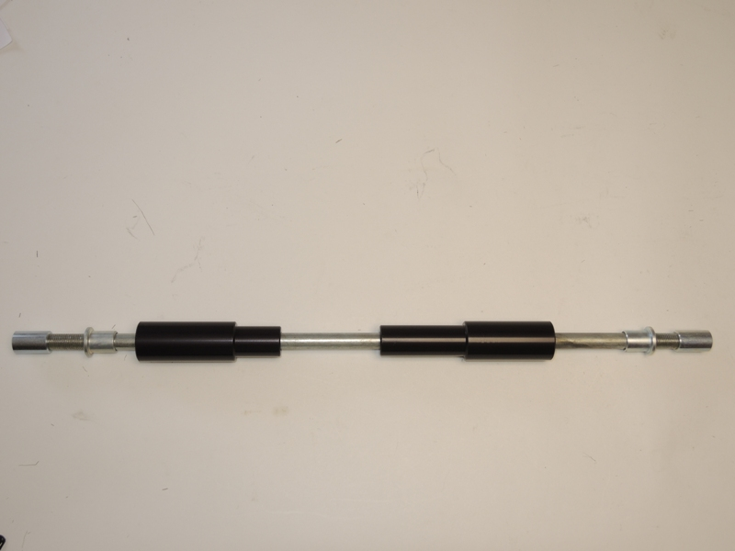
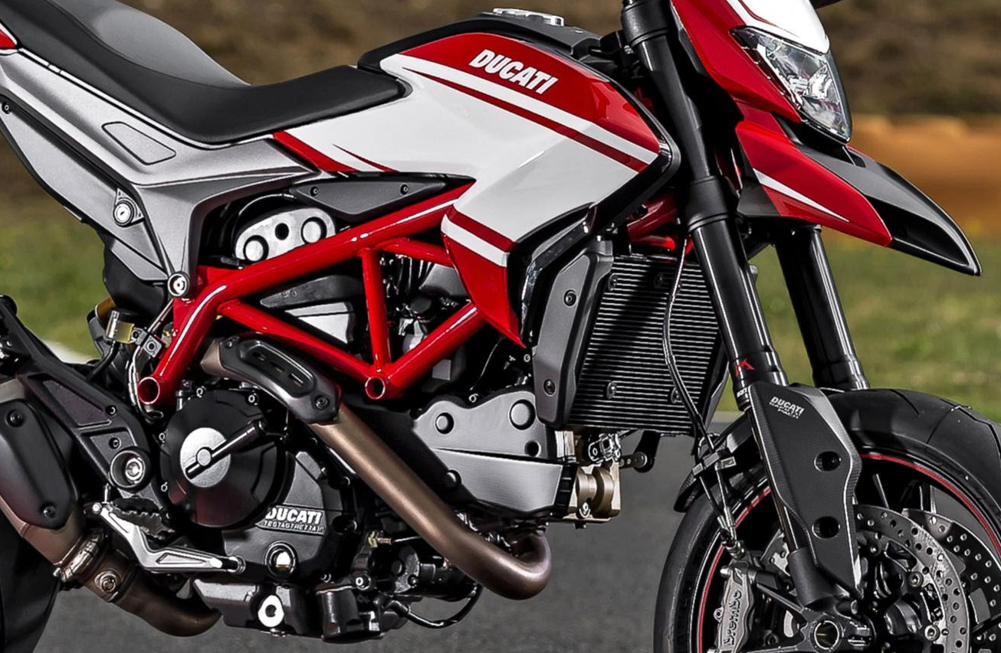
1
1
2
2

We recommend to use the glue on all threads (blue colour – medium strong).

