D16SD
Ducati X-Diavel

Left side kit |  |  |  |  | Right side kit
ID | Description | Cat.no. | Pcs |  |  | ID | Description | Cat.no. | Pcs
1 | Dural. adapter for SLD | 537 | 1 |  |  | 1 | Dural. adapter for SLD | 537 | 1
2 | Dural. nut 65,7mm | 1214 | 1 |  |  | 2 | Dural. nut 68mm | 1215 | 1
3 | Dural. bolt M22x1,5mm | 447 | 1 |  |  | 3 | Dural. bolt M22x1,5mm | 447 | 1
4 | Dural. cylinder 60mm | 14 | 1 |  |  | 4 | Dural. cylinder 60mm | 14 | 1
5 | Bolt M10x80mm | 852 | 1 |  |  | 5 | Bolt M10x80mm | 852 | 1
6 | Bolt M12x75x1,25mm | 914 | 1 |  |  | 6 | Bolt M12x75x1,25mm | 914 | 1
7 | Washer M10 | 801 | 1 |  |  | 7 | Washer M10 | 801 | 1
8 | Bolt M8x25 | 815 | 2 |  |  | 8 | Bolt M8x25 | 815 | 2
9 | Washer M8 | 802 | 2 |  |  | 9 | Washer M8 | 802 | 2

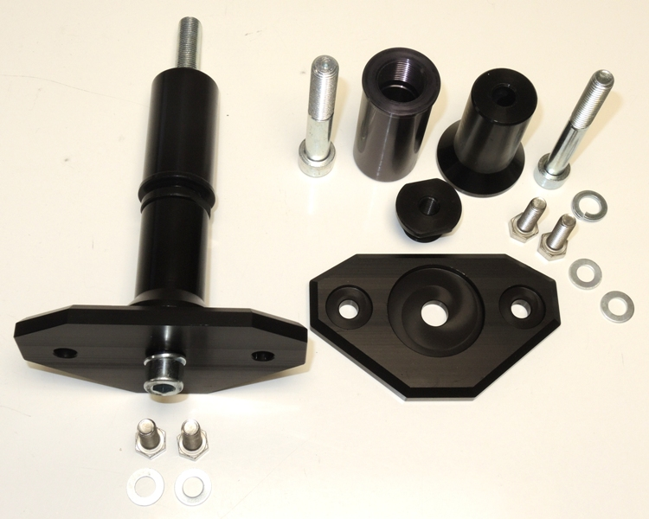

Instructions:

- Remove original bolt M12.
- Insert bolt M12 (ID6) into dural nut ID2 and mount this kit into the frame of motorcycle.
- Mount dural bolt ID3 into the dural nut ID2.
- Now prepare bolt (ID5) and put washer ID7, dural adapter for SLD (ID1) and dural cylinder ID4 on it.
- Mount this kit into the dural bolt ID3.
- Fit slider using two bolts ID8 and washers ID9.

We recommend to use the glue on all threads (medium strong).
