D16S
Ducati X-Diavel

Kit for the left side |  |  |  |  | Kit for the right side
ID | Description | Cat.no. | Pcs. |  |  | ID | Description | Cat.no. | Pcs.
1 | Slider adapter | 315 | 1 |  |  | 1 | Slider adapter | 315 | 1
2 | Dural. threaded cylinder 65,7mm | 1214 | 1 |  |  | 2 | Dural. threaded cylinder 68mm | 1215 | 1
3 | Dural bolt M22x1,5mm | 447 | 1 |  |  | 3 | Dural bolt M22x1,5mm | 447 | 1
4 | Bolt M6x25 mm | 877 | 1 |  |  | 4 | Bolt M6x25 mm | 877 | 1
5 | Bolt M4x16 mm | 876 | 1 |  |  | 5 | Bolt M4x16 mm | 876 | 1
6 | Bolt M10x45mm | 848 | 1 |  |  | 5 | Bolt M10x45mm | 848 | 1
7 | Bolt M12x75x1,25mm | 914 | 1 |  |  | 6 | Bolt M12x75x1,25mm | 914 | 1

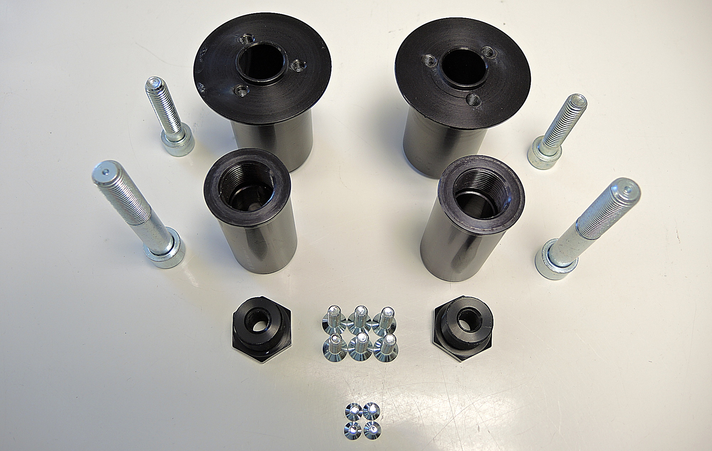

Instructions:

- We recommend to use the glue on all threads.
- Unscrew original bolt from the frame of motorcycle.
- Prepare kit according to the picture below.
Note: Longer threaded cylinder is on the right side.
- Mount this kit into the frame of motorcycle.
- Mount slider using three bolts M6.
- In the end fit coloured cover using two bolts M4.

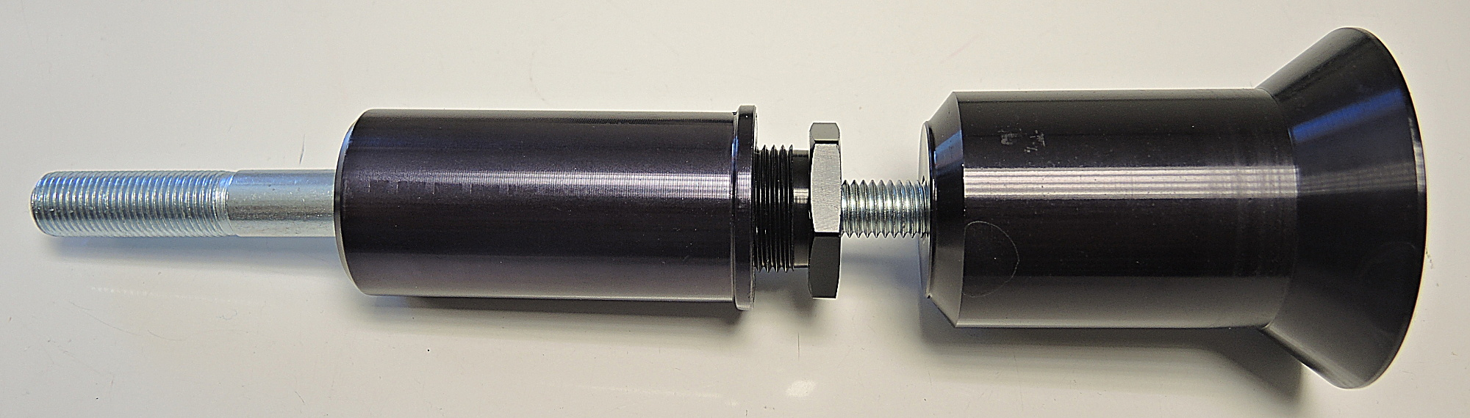
ID7

ID6
