D20SDM
Ducati Multistrada 1260S 2018-

Mounting Kit – Left Side: Mounting Kit – Right Side
ID | Description | Cat.No | Pcs
1 | Galvanized steel nut | X117 | 1
2 | Bolt M10x110x1,25 | 928 | 1
3 | Dural. sleeve l=22mm | 1300 | 1
4 | Dural. sleeve l=4mm | 1260 | 1
5 | Dural. sleeve l=70mm | 15 | 1
6 | Bolt M6x20 | 1024 | 2
7 | Washer M6 | 1023 | 2
8 | Dural. adapter SLDM | 537/B | 1
9 | Spring washer | 801 | 1
10 | Stainless steel rod 12(1,25)x260x30x30 |  | 1
ID | Description | Cat.No | Pcs
1 | Galvanized steel nut | X117 | 1
2 | Bolt M10x110x1,25 | 928 | 1
3 | Dural. sleeve l=22mm | 1300 | 1
4 | Dural. sleeve l=4mm | 1260 | 1
5 | Dural. sleeve l=70mm | 15 | 1
6 | Bolt M6x20 | 1024 | 2
7 | Washer M6 | 1023 | 2
8 | Dural. adapter SLDM | 537/B | 1
9 | Spring washer M10 | 801 | 1

For the left and right side connection, use stainless steel rod ID 10 (length 260mm, threads M12x1,25 mm at the both sides) that is included in the mounting kit

Mounting:
1. Remove the original Bolt M12 from the frame.
2. Insert the stainless steel rod ID 10 into the frame
3. Insert the sleeve ID 4 from the left and right side. Screw in the galvanized nut ID 1 (tighten against each other) and fit the sleeve ID 3
4. Place the washer M10 ID 9, Dural. adapter SLDM ID8 and dural. sleeve ID 5 on the bolt M10 ID
5. Screw this set through the sleeve ID 3 into the galvanized nut ID 1 in the motorcycle frame
6. Tighten both sides.
9. Install slider using bolt M6 ID 6 and washer M6 ID 7
Warning! We recommend using medium strength thread glue (blue) during assembly.
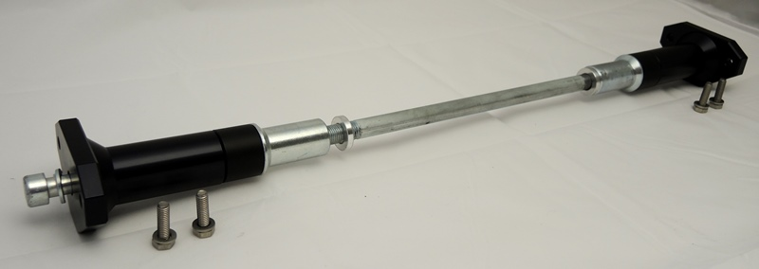
4
1
6
3
2
10
5
7
8
9

