D20S
Ducati Multistrada 1260S 2018-

Mounting Kit – Left Side: Mounting Kit – Right Side:
ID | Description | Cat.No | Pcs
1 | Galvanized steel nut | X117 | 1
2 | Bolt M10x100x1,25 | 892 | 1
3 | Dural. sleeve l=22mm | 1300 | 1
4 | Dural. sleeve l=4mm | 1260 | 1
5 | Dural. sleeve l=50mm | 5 | 1
6 | Dural. Sl adapter l=20mm | 1137 | 1
7 | Bolt M6x25 | 877 | 3
8 | Bolt M4x16 | 876 | 2
9 | Stainless steel rod 12(1,25)x260x30x30 |  | 1
ID | Description | Cat.No | Pcs
1 | Galvanized steel nut | X117 | 1
2 | Bolt M10x105x1,25 | 892 | 1
3 | Dural. sleeve l=22mm | 1300 | 1
4 | Dural. sleeve l=4mm | 1260 | 1
5 | Dural. sleeve l=50mm | 5 | 1
6 | Dural. Sl adaptér d=20mm | 1137 | 1
7 | Bolt M6x25 | 877 | 3
8 | Bolt M4x16 | 876 | 2

For the left and right side connection, use stainless steel rod ID 9 (length 260mm, threads M12x1,25 mm at the bothsides) that is included in the mounting kit.

Mounting:
1. Remove the original Bolt M12 from the frame.
2. Insert the stainless steel rod ID 9 into the frame.
3. Insert the sleeve ID 4 from the left and right side. Screw in the galvanized nut ID 1 (tighten against each other) and fit the sleeve ID 3
4. Place the steel insert ID 6 and sleeve ID 5 on the bolt M10 ID 2.
5. Screw this set through the sleeve ID 3 into the galvanized nut ID 1 in the motorcycle frame
8. Tighten both sides
9. Install slider using Bolt ID 7 and Dural plate using bolt ID 8

Warning! We recommend using medium strength thread glue (blue) during assembly.
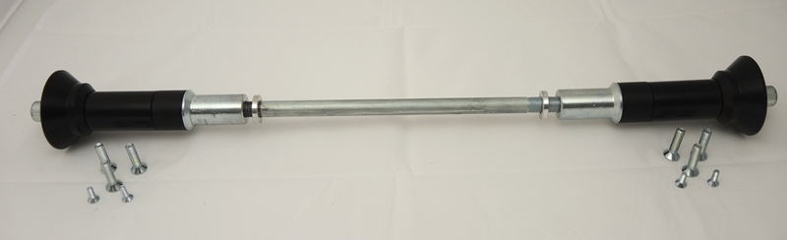
4
4
1
1
6
2
3
3
2
6
7
5
5
7
8
7
8

