D20
Ducati Multistrada 1260S 2018-

Mounting kit - Left Side: Mounting kit - Right Side:
ID | Description | Cat.No | Pcs
1 | Galvanized steel nut | X117 | 1
2 | Bolt M10x105x1,25 | 893 | 1
3 | Dural. sleeve l=22mm | 1300 | 1
4 | Dural. sleeve l=4mm | 1260 | 1
5 | Dural. sleeve l=50mm | 5 | 1
6 | Steel insert | X1 | 1
7 | Stainless steel rod 12(1,25)x260x30x30 |  | 1
ID | Description | Cat.No | Pcs
1 | Galvanized steel nut | X117 | 1
2 | Bolt M10x105x1,25 | 893 | 1
3 | Dural. sleeve l=22mm | 1300 | 1
4 | Dural. sleeve l=4mm | 1260 | 1
5 | Dural. sleeve l=50mm | 5 | 1
6 | Steel insert | X1 | 1

For the left and right side connection, use stainless steel rod ID 7 (length 260mm, threads M12x1,25 mm at the bothsides) that is included in the mounting kit.

Mounting:
1. Remove the original Bolt M12 from the frame.
2. Insert the stainless steel rod ID 7 into the frame.
3. Insert the sleeve ID 4 from the left and right side. Screw in the galvanized nut ID 1 (tighten against each other) and fit the sleeve ID 3
4. Place the steel insert ID 6, crash protector and sleeve ID 5 on the bolt M10 ID 2.
5. Screw this set through the sleeve ID 3 into the galvanized nut ID 1 in the motorcycle frame.
6. Tighten both sides

We recommend using medium strength thread glue (blue) during assembly.

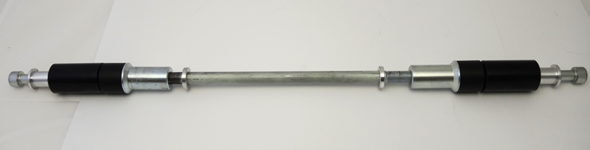
4
4
1
1
6
2
3
3
2
6
7
5
5

