D3SDM
Ducati Multistrada 1000
Kit for left side: Kit for right side:

ID | Description | Cat.No | Qty
1 | Bracket for SLDM | 537/B | 1
2 | Dural.adapter (cone) | 149 | 1
3 | Dural. adapter d=70 | 62 | 1
4 | Bolt M6x20 | 1024 | 2
5 | Washer M6 | 1023 | 2
6 | Washer M12 | 803 | 1
7 | Nut M12 | 811 | 1
8 | Dural.cylinder d=25mm | 1171 | 1
9 | Steel bar M12x470mm |  | 1

For connect both side use steel bar L=470mm.
ID | Popis | Kat.číslo | Počet
1 | Bracket for SLDM | 537/B | 1
2 | Dural.adapter (cone) | 149 | 1
3 | Dural. adapter d=70 | 62 | 1
4 | Bolt M6x20 | 1024 | 2
5 | Washer M6 | 1023 | 2
6 | Washer M12 | 803 | 1
7 | Nut M12 | 811 | 1

Assembly instruction:

1. Take out original bolt from frame.
2. Replace original bolt, steel bar ID.9.
3. From left side insert dural.cylinder d=25mm ID.8 and after that put on the steel bar dural. adapter ID.3 and dural adapter (cone) ID.2
4. put the brackets for SLD ID.1 on the left and right side
5. thighten this set by nuts and washers ID.6 and ID.7
6. Mounting slider , use bolts and washers ID.4 a ID.5 for the left and right side
Warning, we recommended use glue on the all threads.

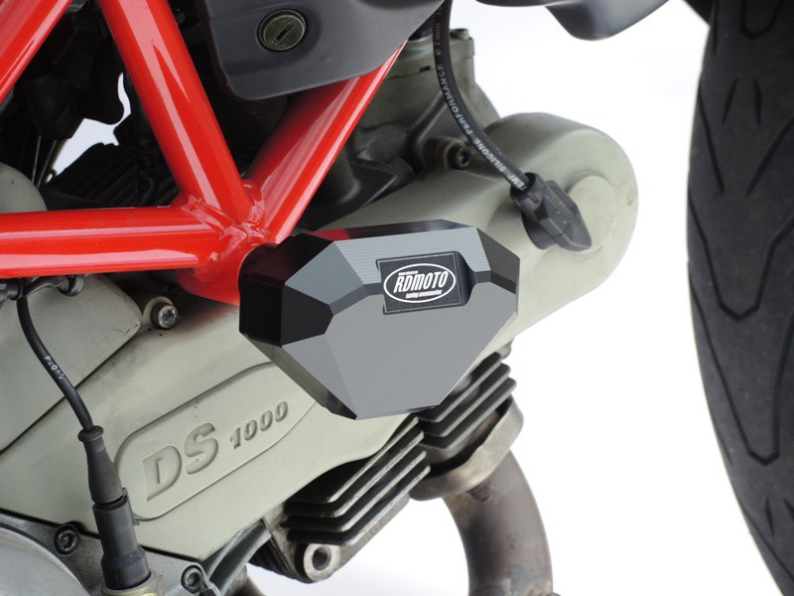
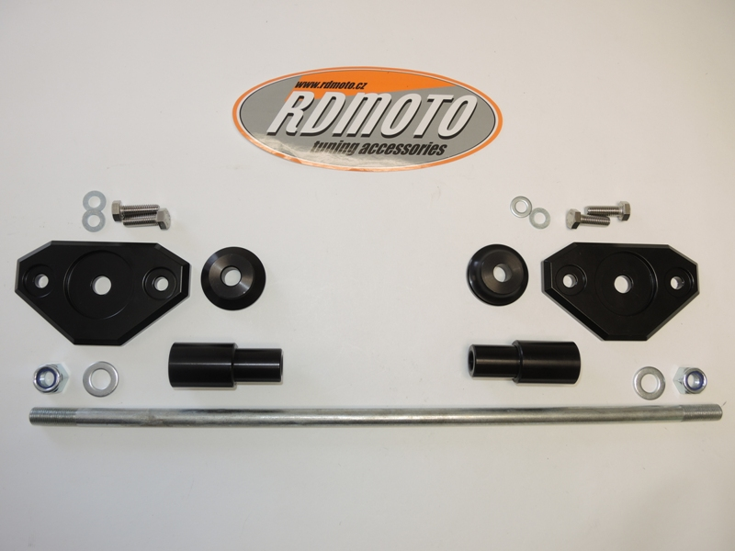
3
3
3
2

