D3
Ducati Multistrada 1000
Kit for left side: Kit for right side:

ID | Description | Cat.N | Qt
1 | Dural.spacer | 62 | 1
2 | Nut M12 | X12/X2 | 1
3 | Dural.spacer d=25mm | 1171 | 1
4 | Steel bar M12x425x1,25mm |  | 1

ID | Description | Cat.N | Qt
1 | Dural.spacer | 62 | 1
2 | Nut M12 | X12/X2 | 1
For connecting left and right side use steel bar ID.4
Instruction to assembly:

1. Take out original long bolt M12 from frame.
2. Into the frame insert steel bar ID.4. This bar replace original bolt.
3. Put dural.spacer ID.3 from left side into the frame after this place ID.1 into the frame from left side. On the bar insert ID.1 from right side.
4. For tightening protectors use nuts ID.2

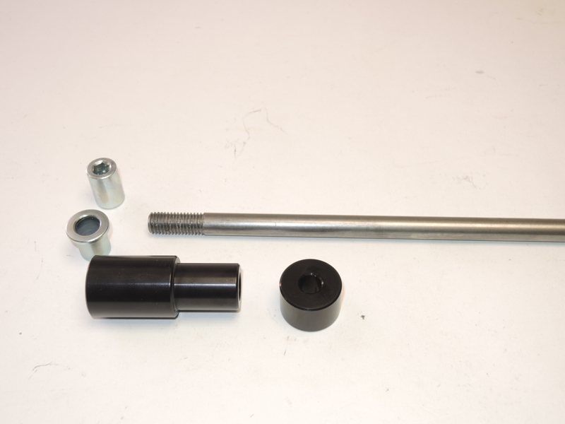
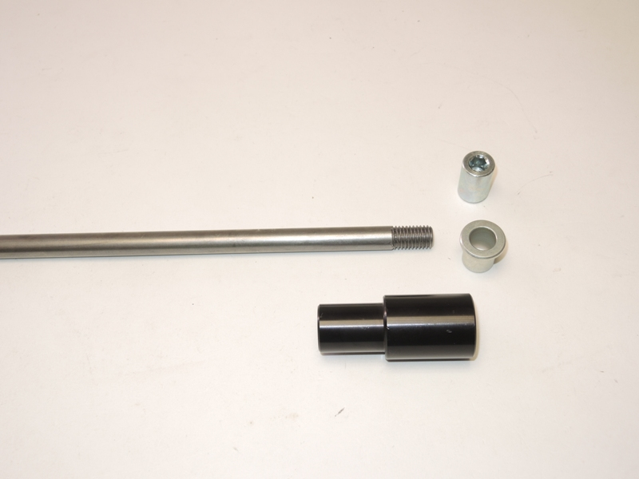
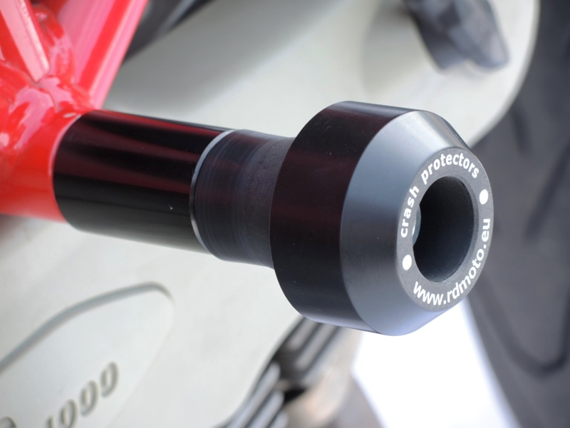
Use glue of threads, for safety mounting. Medium strong.
3
3
3
2
1
1
4

