D4SDM
Ducati Monster 696 2008-
Ducati Monster 796 2010-
Ducati Monster 1100/1100S 2009-

Kit for the left side: Kit for the right side:
ID | Description | Cat.no | Pcs
1 | Dural. adapter | 41 | 1
2 | Dural. cylinder | 149 | 1
3 | Nut M12 | 811 | 1
4 | Dural. adapter for SLDM | 537/B | 1
5 | Bolt M6x20 | 1024 | 2
6 | Washer M6 | 1023 | 2
7 | Rod 12x445x30x30 |  | 1
ID | Description | Cat.no | Pcs
1 | Dural. adapter | 41 | 1
2 | Dural. cylinder – 30mm | 171 | 1
3 | Nut M12 | 811 | 1
4 | Dural. adapter for SLDM | 537/B | 1
5 | Bolt M6x20 | 1024 | 2
6 | Washer M6 | 1023 | 2

Instructions:

1. Remove original bolt M12 from the frame of motorcycle.
2. Insert stainless steel rod through the frame ID7
3. Put adapters ID1 from both sides on rod.
4. Then put dural cylinder on ID2 rod.
7. Put dural adapter for SLD ID4 on rod.
8. Tighten this kit using nuts ID3.
9. Fit protector using bolts ID5 and washers ID6.

We recommend to use the glue on all threads (medium strong).

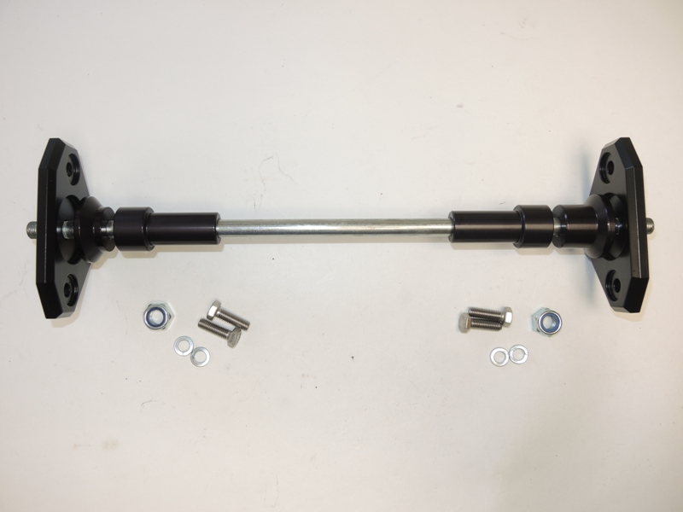

4
2
4
1
7
1
2

3
3
5
6
5
6
