D4S
Ducati Monster 696 2008-
Ducati Monster 796 2010-
Ducati Monster 1100/1100S 2009-

Kit left side: Kit right side:
ID | Description | Cat.N | Qty
1 | Dural.adapter | 302 | 1
2 | Bolt M6x25 | 877 | 3
3 | Bolt M4x16 | 876 | 2
4 | Steel nut M12 | X12 | 1
5 | Inox rod M12x365x1,25mm | N1 | 1
ID | Description | Cat.N | Qty
1 | Dural.adapter | 302 | 1
2 | Bolt M6x25 | 877 | 3
3 | Bolt M4x16 | 876 | 2
4 | Steel nut M12 | X12 | 1

For connect left and right side use inox rod ID.5.
Assembly :
1. Dismantle orig. bolt M12 from frame.
2. Insert inox rod ID.5.
3. From left and right side put dural.adapter ID.1.
4. Tighten adapters by nuts ID.4.
7. Put on sliders and use bolts ID.2.
8. Insert colour avers and use bolts ID.3.

Warning: We recommend use the glue of all threads. Medium strong.

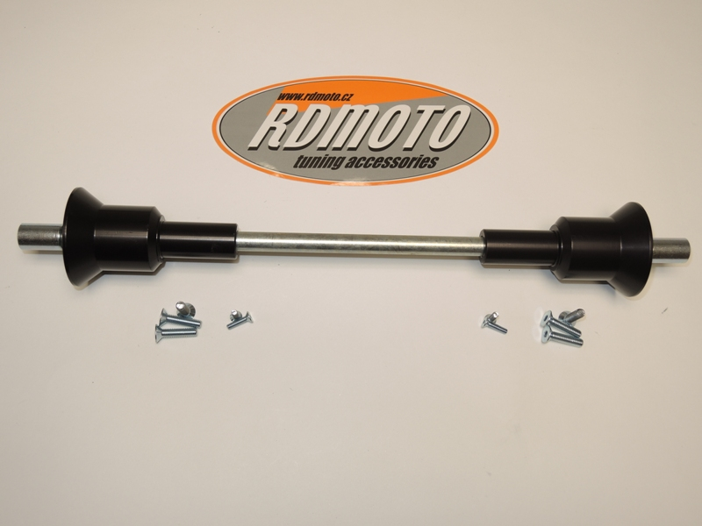

1
4
4
1

5

2
3
3
2

