D5SDM
Ducati Hypermotard 796 2010-
Hypermoterd 796/ Streetfighter 1098

Mounting Kit - Left Side: Mounting Kit - Right Side:
ID | Description | Cat.No | Pcs
1 | Moto adapter | 257 | 1
2 | Bolt M6x20 | 1024 | 2
3 | Washer M6 | 1023 | 2
4 | Dural. sleeve | 56 | 1
5 | Lock nut M12 | 811 | 1
6 | SLDM adapter | 537/B | 1
7 | Stainless steel rod M12x455x30x30mm | N1 | 1
ID | Description | Cat.No | Pcs
1 | Moto adapter | 257 | 1
2 | Bolt M6x20 | 1024 | 2
3 | Washer M6 | 1023 | 2
4 | Dural. sleeve | 56 | 1
5 | Lock nut M12 | 811 | 1
6 | SLDM adapter | 537/B | 1

To connect the left and right sides, the mounting kit includes a stainless steel rod ID.7 with a length of 455 mm and threads M12x1.5mm.

Mounting instructions:
1. Remove original bolt M12 from the frame.
2. Insert the rod M12x455 ID.7 through the frame.
3. Place the dural. sleeves ID.4, adapters ID.1 and SLDM adapters ID.6 on the both sides of the rod.
4. Tighten the adapters with nut ID.5.
5. Insert the slider and fasten it using bolts ID.2 and washers ID.3
Warning: We recommend using medium strength (blue) thread glue during assembly.

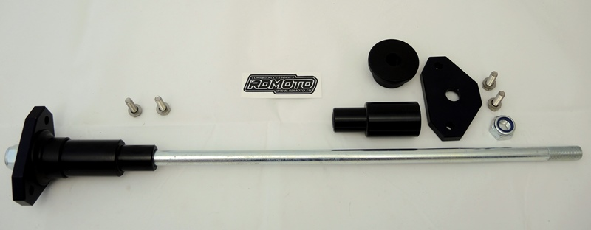
4
4
1
1
5
2
3
3
2
6
3
5
6
7
