D5SD
Ducati Hypermotard 796 2010-
Hypermoterd 1100/ Streetfighter 1098

Mounting Kit - Left Side: Mounting Kit - Right Side:
ID | Description | Cat.No | Pcs
1 | Moto adapter | 257 | 1
2 | Bolt M8x25 | 815 | 2
3 | Washer M8 | 800 | 2
4 | Dural. sleeve | 56 | 1
5 | Lock nut M12 | 811 | 1
6 | SLD adapter | 537 | 1
7 | Stainles steel rod M12x455x30x30mm | N1 | 1
ID | Description | Cat.No | Pcs
1 | Moto adapter | 257 | 1
2 | Bolt M8x25 | 815 | 2
3 | Washer M8 | 800 | 2
4 | Dural. sleeve | 56 | 1
5 | Lock nut M12 | 811 | 1
6 | SLD adapter | 537 | 1

To connect the left and right sides, the mounting kit includes a stainless steel rod ID.7 with a length of 455 mm and threads M12x1.5mm.

Mounting instructions:
1. Remove original bolt M12 from the frame.
2. Insert the rod M12x455 ID.7 through the frame.
3. Place the dural. sleeves ID.4, adapters ID.1 and SLD adapters ID.6 on the both sides of the rod.
4. Tighten the adapters with nut ID.5.
5. Insert the slider and fasten it using bolts ID.2 and washers ID.3.

Warning: We recommend using medium strength (blue) thread glue during assembly.
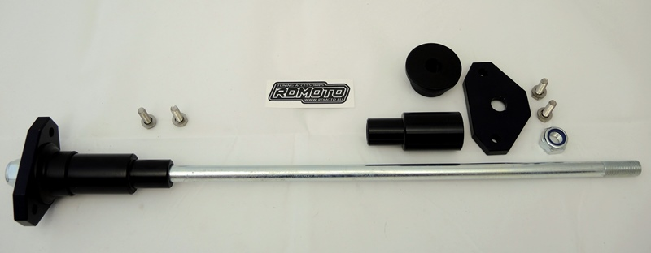
4
4
1
1
5
2
3
3
2
6
3
5
6
7
