D5S
Ducati Hypermotard 796/1100 2010-

Mounting kit for the left: Mounting kit for the right:
ID | Description | Cat.no. | pcs
1 | Moto adapter | 302 | 1
2 | Bolt M6x25 | 877 | 3
3 | Bolt M4x16 | 876 | 2
4 | Steel nut M12 | X12 | 1
5 | Stainless steel rod M12x365x1,25mm | N1 | 1
ID | Description | Cat.no. | pcs
1 | Moto adapter | 302 | 1
2 | Bolt M6x25 | 877 | 3
3 | Bolt M4x16 | 876 | 2
4 | Steel nut M12 | X12 | 1

Use Stainless steel rod (ID5) for connecting both sides.

Installation:

- Remove original bolt M12 from the frame of motorcycle.
- Insert stainless steel rod (ID5) into the frame of motorcycle.
- Tighten both adapters using nut (ID4).
- Fit slider and tighten it using bolts (ID2).
- Insert coloured cover into slider and tighten it using two botls (ID3).

We recommend to use the glue on all threads (medium strong – blue colour).

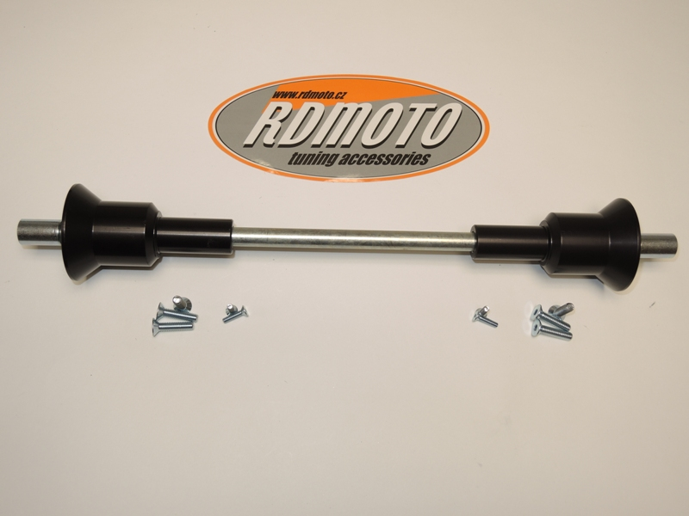
4
4
1
1
5
2
3
3
2
Streetfighter 1098
