D6SDM
Ducati Streetfighter 848 2012-

Kit for left side: Kit for right side:
ID. | Description | Cat.N | Qt.
1 | Alu. bracket for SLDM | 537/B | 1
2 | Alu. spacer d=65 | 41 | 1
3 | Alu. cone spacer | 149 | 1
4 | Safety nut M12 | 811 | 1
5 | Bolt M6x20 | 1024 | 2
6 | Washer M6 | 1023 | 2
7 | Steel rod 12x420x30x30 |  | 1
ID. | Description | Cat.N | Qt.
1 | Alu. bracket for SLDM | 537/B | 1
2 | Alu. spacer d=65 | 41 | 1
3 | Alu. cone spacer | 149 | 1
4 | Safety nut M12 | 811 | 1
5 | Bolt M6x20 | 1024 | 2
6 | Washer M6 | 1023 | 2

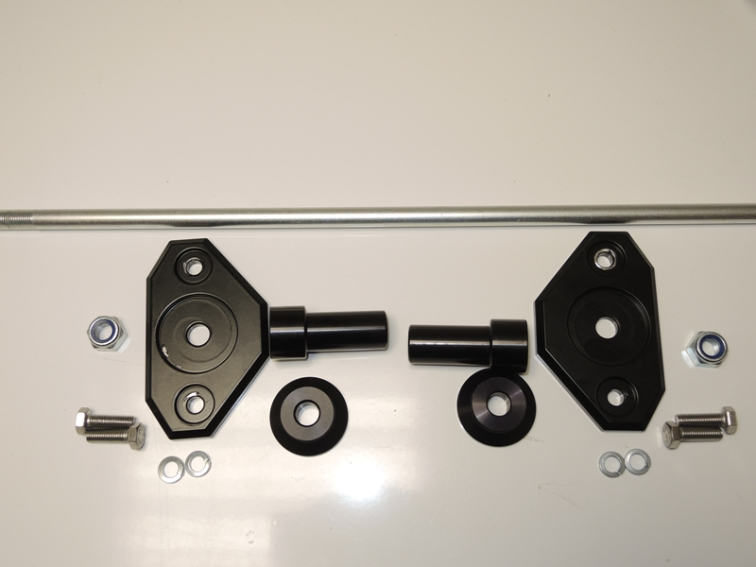
6
3
4
1
2
3
2
1
6
5
4
7
5

Assembly instruction:

- Dismantle original bolt M12 from frame.
- Place steel rod ID.7 throught the engine, replace orignal bolt.
- Place alu. adapters ID.2 insert on the steel rod from both sides. Smaller diameter into the frame.
- Put cone alu. spacers ID.3 from left and right side on the steel rod.
- Place alu. bracket ID.1 on the steel rod.
- This kit tighten by nuts ID.4.
- Place sliders and fixed it by bolts and washers ID.5 and ID.6.

Warning - on the threads of the screws we recommend using premium adhesive moderate (blue).

