D7SDM
Ducati Diavel 2011-

Mounting Kit - Left Side: Mounting Kit - Right Side:
ID | Popis | Kat.č | Ks
1 | Lock nut M12 | 811 | 1
2 | Dural. sleeve l=103mm | 457 | 1
3 | Dural. SLDM adapter | 537/B | 1
4 | Dural. sleeve l=23,5 | 257 | 1
5 | Bolt M6x20 | 1024 | 2
6 | Washer M6 | 1023 | 2
7 | Stainless steel rod M12x550 |  | 1
ID | Popis | Kat.č | Ks
1 | Lock nut M12 | 811 | 1
2 | Dural. sleeve l=128mm | 458 | 1
3 | Dural. SLDM adapter | 537/B | 1
4 | Dural. sleeve l=23,5 | 257 | 1
5 | Bolt M6x20 | 1024 | 2
6 | Washer M6 | 1023 | 2

Mounting instructions::
- Remove original bolt M12 from the frame.
- Insert the rod M12x550 ID.7 through the frame.
- Place the dural. sleeves ID.2 on the both sides of the rod. Left side l=103mm, right side l=128mm.
- Insert sleeves ID.4 and SLDM adapters ID.3 on the both sides.
- Tighten with nuts ID.1.
- Insert the slider and fasten it using bolts M8 ID.5 and washers M8 ID.6.

Illustration photo of the assembly site:

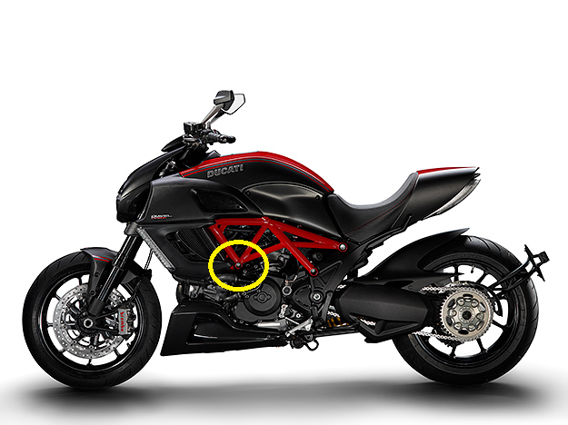
1

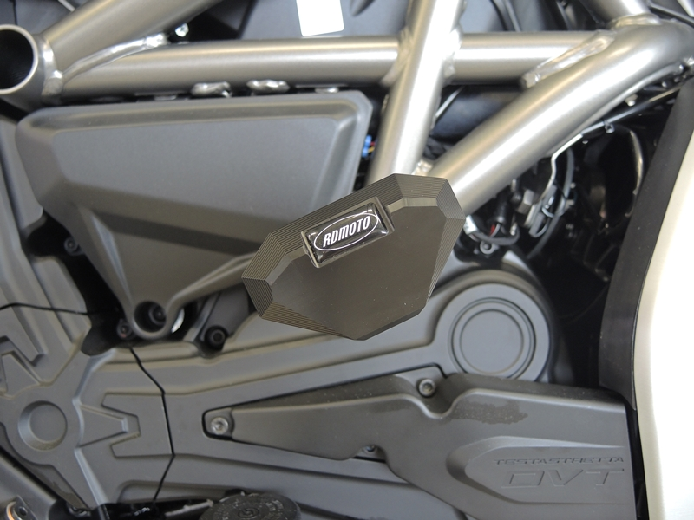

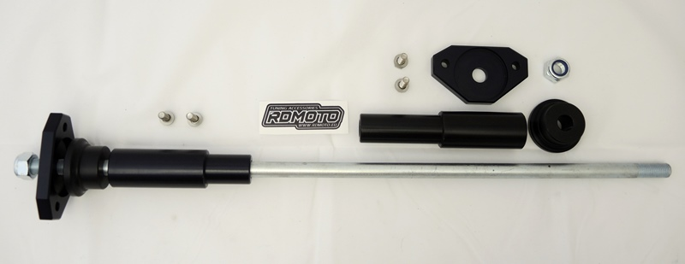
Warning: We recommend using medium strength (blue) thread glue during assembly.
2
1
2
4
3
5
6
4
2
7
3
1

