D7S
Ducati Diavel 2011-

Kit for the left side: |  |  |  |  | Kit for the right side:
ID. | Description | Cat.no. | Pcs |  |  | ID. | Description | Cat.no. | Pcs
1 | Dural.cylinder d=103mm | 457 | 1 |  |  | 1 | Dural.cylinder d=128mm | 458 | 1
2 | Adapter SL01 | DV-314 | 1 |  |  | 2 | Adapter SL01 | DV-314 | 1
3 | Steel nut M12 | X12 | 1 |  |  | 3 | Steel nut M12 | X12 | 1
4 | Bolt M6x25 | 877 | 3 |  |  | 4 | Bolt M6x25 | 877 | 3
5 | Bolt M4x16 | 876 | 2 |  |  | 5 | Bolt M4x16 | 876 | 2
6 | Stainless steel bar M12x520x1,25mm  12x(1,25)x520x30x30 |  | 1

Installation:

1. remove the original screw
2. insert steel bar through motorcycle frame ID.6
3. from the left and right side insert duralumin cylinders ID.1 and adapters ID.2
4. tighten it by special nuts ID.3
5. Install slider, use bolts ID.4
6. insert cap into the slider, use screw ID.5

Warning – we recommend to use safety glue on threads of all bolts (moderate strong – blue colour).
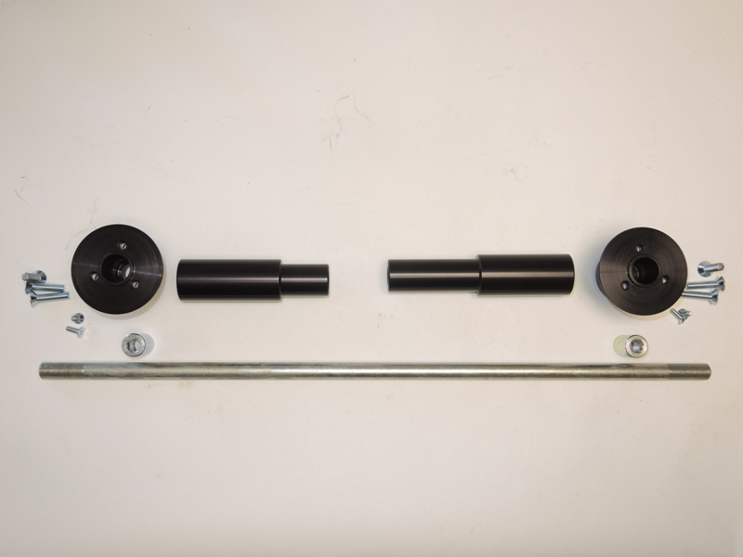
Illustration photo :
4
2
1
4
1
2
6
5
3
3
5
