D7
Ducati Diavel 2011-

Fitting kit left side: Fitting kit right side:
ID | Description | Cat.n | QTY
1 | Steel nut M12 | X12/X2 | 1
2 | Duralumin cylinder d=103mm | 457 | 1
 | Bar 12(1,25)x500x30x30 |  | 1
ID | Description | Cat.n | QTY
1 | Steel nut M12 | X12/X2 | 1
2 | Duralumin cylinder d=128mm | 458 | 1

Instruction to assembly:
- remove the long original bolt M12
- give the stainless steel bar M12x500x1,25mm through the frame
- give duralumin cylinders ID.2 on this bar both sides. From left side lenght 103mm.
- finaly screw up all with nuts M12 ID.1

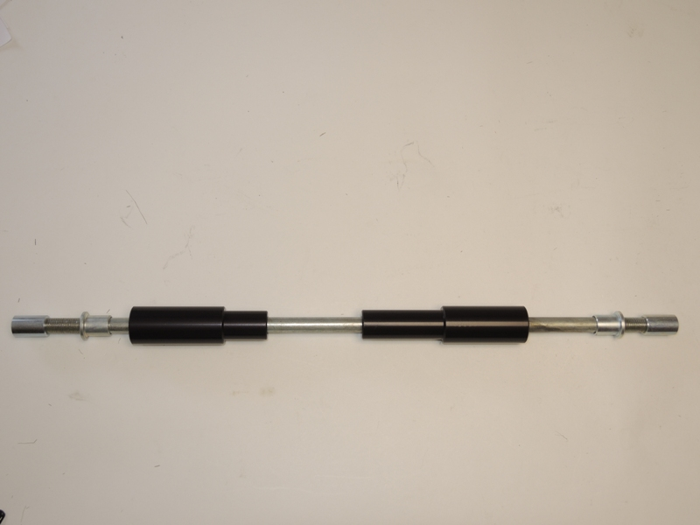
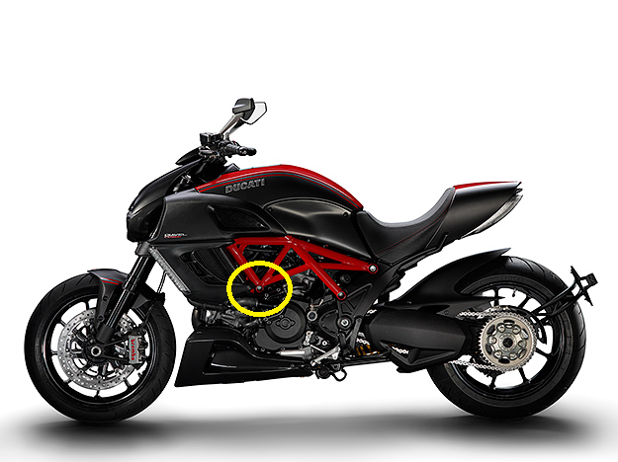
1
1
2
2
Warning: We recommend use the glue of all threads. Medium strong.

