D8SDM
Ducati Monster 821/1200 ´14

Left side kit: Right side kit:

ID | Description | Cat.no | Pcs
1 | Frame | 520 | 1
2 | Cylinder 80,5mm (front) | 1177 | 1
3 | Cylinder 75 mm (rear) | 1178 | 1
4 | Bolt M12x150x1,25 (front) | 984 | 1
5 | Bolt M12x140x1,25 (rear) | 995 | 1
6 | Washer M12 | 803 | 1
7 | Bolt M10x40 | 854 | 1
8 | Dural. adapter | 10 | 1
9 | Dural. adapter for SLDM | 537/B | 1
10 | Bolt M6x20 | 1024 | 2
11 | Washer M6 | 1023 | 2
12 | Plastic cover M12 | X60 | 2

ID | Description | Cat.no. | Pcs
1 | Frame | 531 | 1
2 | Cylinder 47,5mm (front) | 1179 | 1
3 | Cylinder 82 mm (rear) | 1180 | 1
4 | Bolt M12x120x1,25 (front) | 913 | 1
5 | Bolt M12x140x1,25 (rear) | 995 | 1
6 | Washer M12 | 803 | 1
7 | Bolt M10x10 | 854 | 1
8 | Dural. adapter | 10 | 1
9 | Dural. adapter SLDM | 537/B | 1
10 | Bolt M6x20 | 1024 | 2
11 | Washer M6 | 1023 | 2
12 | Plastic cover M12 | X60 | 2
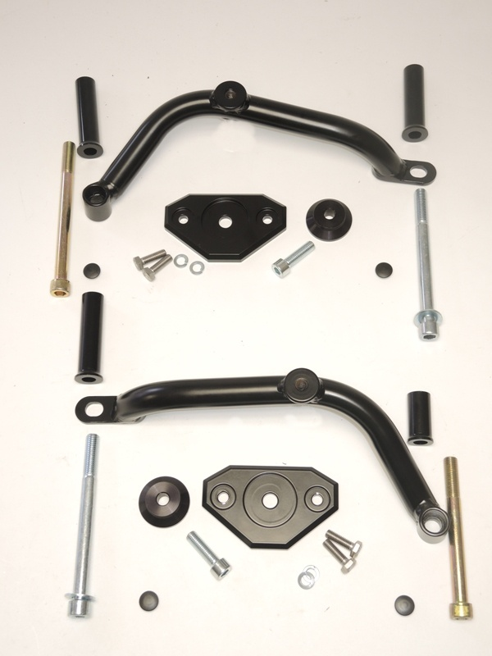
Left side
3
11
picture.1

1
2

4
9
5
8
10

7
11
6

1
3

Right side
2

9
4
8

6
5
8
10
7
11

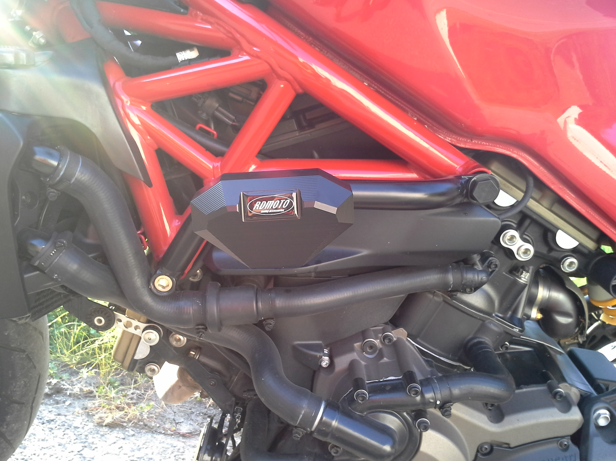

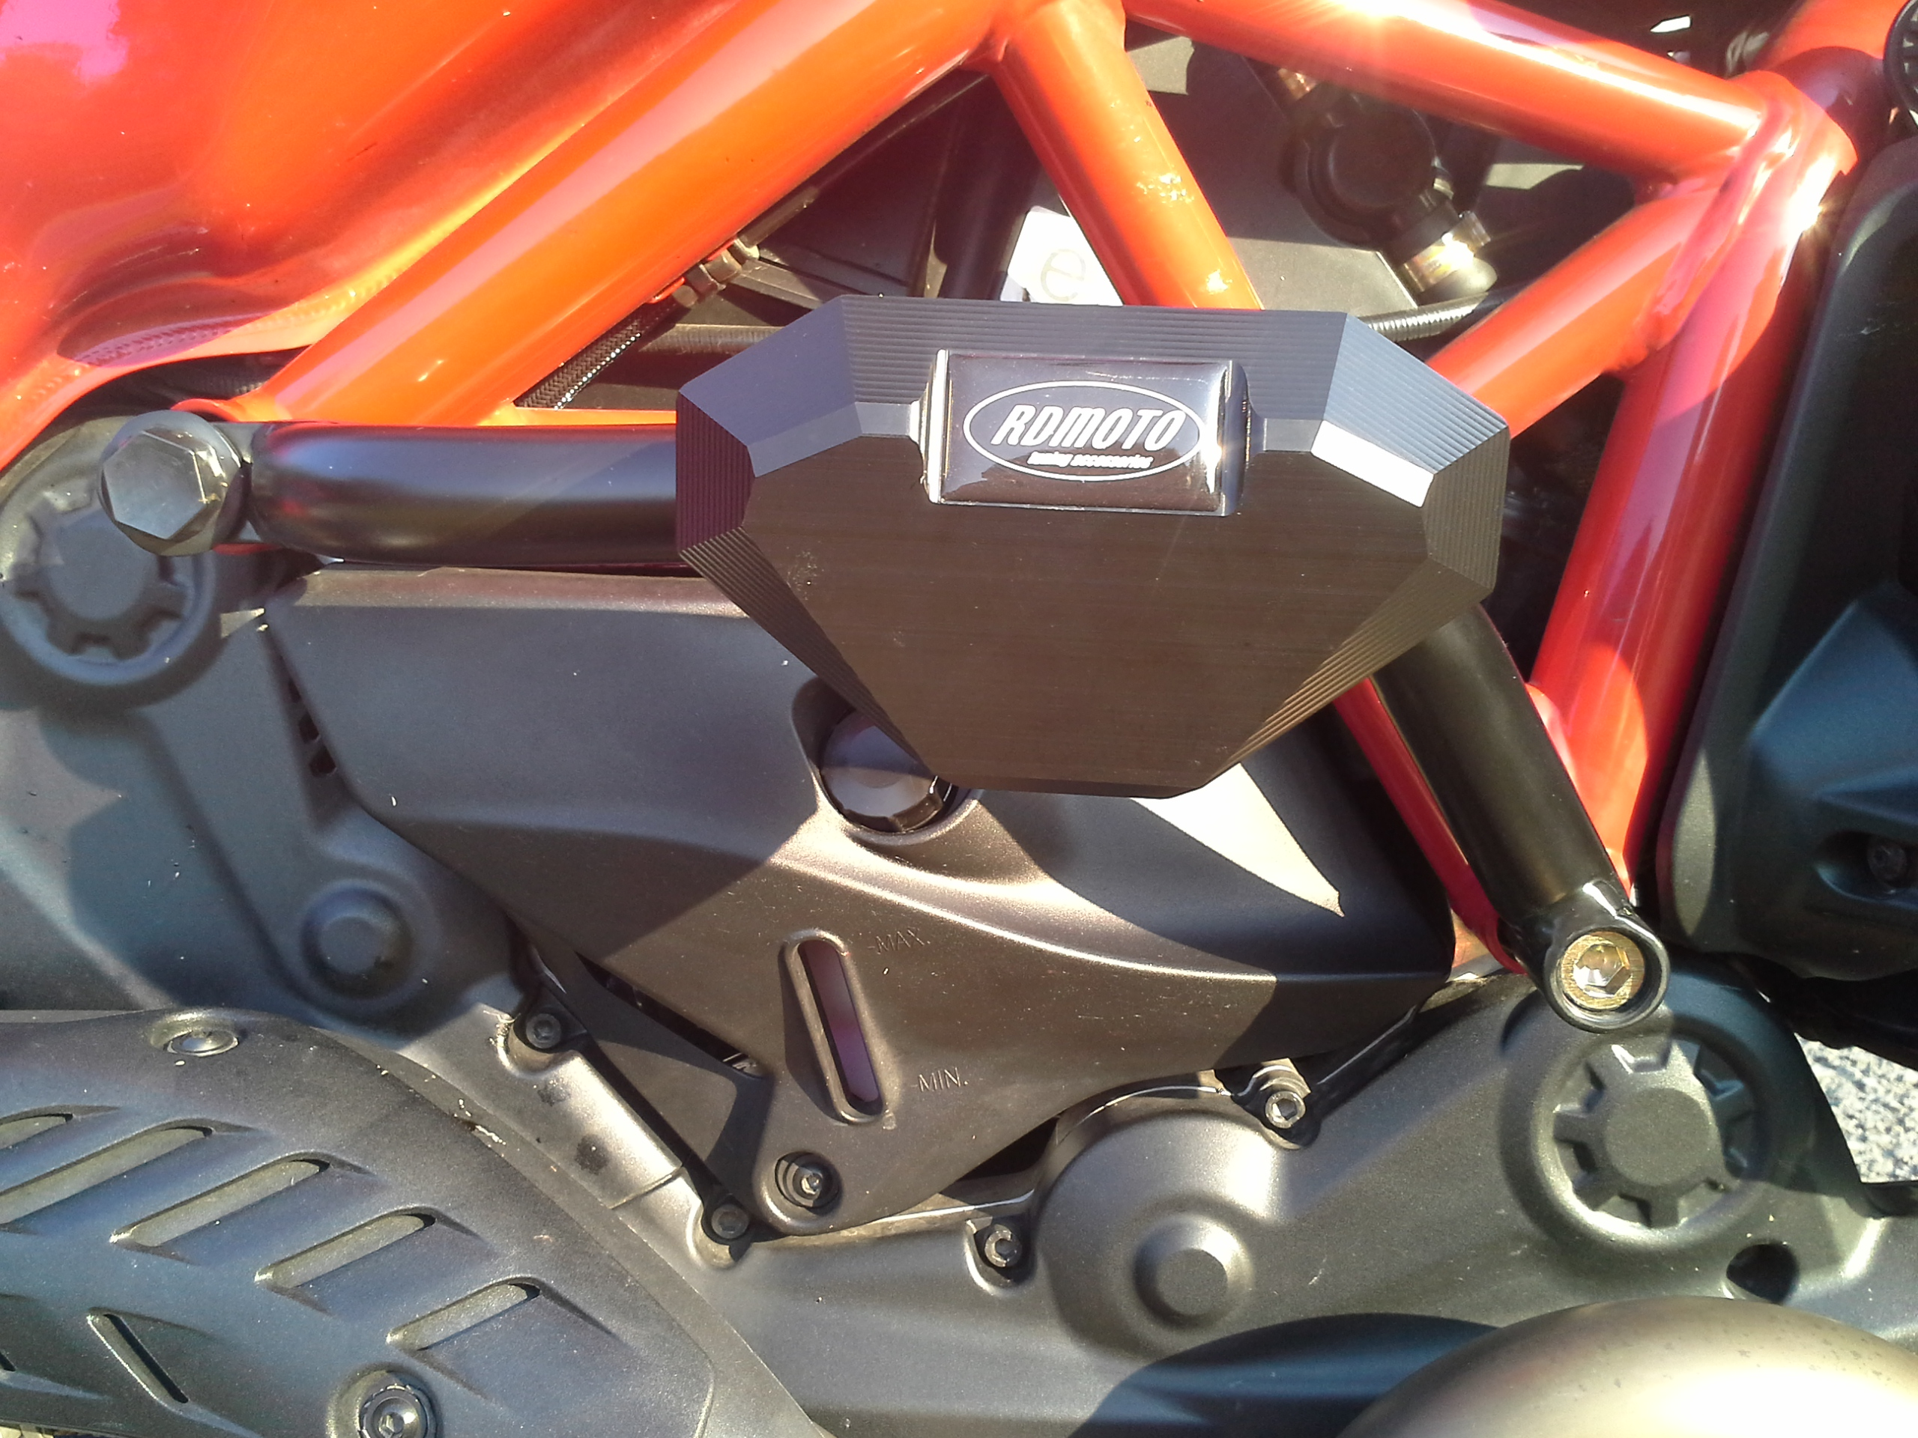

- Remove original bolts from the frame of motorcycle.
- Insert dural cylinders (ID2 + ID3) into the frame of motorcycle.
- Mount frame ID1 on the frame of motorcycle using bolts ID4 and ID5+ID6.
- Place plastic covers on bolts.
- Put dural adapter ID9 and SLD adapter ID8 on bot ID7. Mount this kit into the frame.
- Mount slider using two M8 bolts + washers.

We recommend to use the glue on all threads (medium strong).

