D8S
Ducati Monster 821/1200 ´14

Left side kit: Right side kit:
ID | Description | Cat.no | Pcs
1 | Frame | 520 | 1
2 | Cylinder 80,5mm (front) | 1177 | 1
3 | Cylinder 75 mm (rear) | 1178 | 1
4 | Bolt M12x150x1,25 (front) | 984 | 1
5 | Bolt M12x140x1,25 (rear) | 995 | 1
6 | Washer M12 | 803 | 1
7 | Bolt M10x30 | 882 | 1
8 | Dural. adapter for SLD | 292 | 1
9 | Bolt M6x25 | 877 | 3
10 | Bolt M4x16 | 876 | 2
11 | Plastic cover M12 | X60 | 2
12

ID | Description | Cat.no. | Pcs
1 | Frame | 531 | 1
2 | Cylinder 47,5mm přední | 1179 | 1
3 | Cylinder 82 mm zadní | 1180 | 1
4 | Bolt M12x120x1,25 přední | 913 | 1
5 | Bolt M12x140x1,25 zadní | 995 | 1
6 | Washer M12 | 803 | 1
7 | Bolt M10x30 | 882 | 1
8 | Dural. adapter for SLD | 292 | 1
9 | Bolt M6x25 | 877 | 3
10 | Bolt M4x16 | 876 | 2
11 | Plastic cover M12 | X60 | 2
12

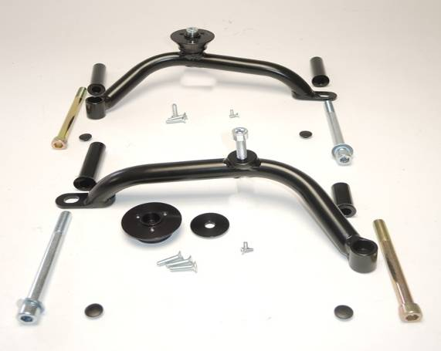
7
8
Left side
3
1
2

10
9
5
4
11
10
6

1
Right side
7
2
3

10
5
4

6
8
9
12
11

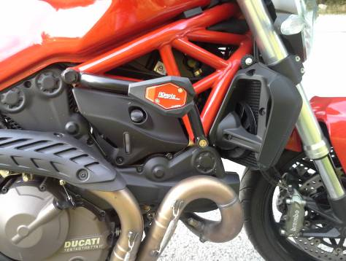

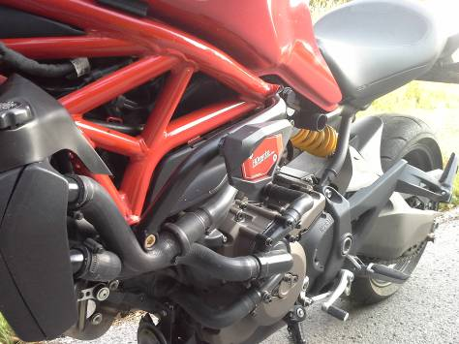

- Remove original bolts from the frame of motorcycle.
- Insert dural cylinders (ID2 + ID3) into the frame of motorcycle.
- Mount frame ID1 on the frame of motorcycle using bolts ID4 and ID5+ID6.
- Place plastic covers on bolts.
- Put dural adapter ID8 on the bolt ID7. Mount this kit on the frame.
- Fit slider using bolts ID9.
- Fit cover using bolts ID10.

We recommend to use the glue on all threads (medium strong).

