D8
Ducati Monster 821/1200 ´14

Left side mounting kit: Right side mounting kit:

ID | Description | Cat.N | Qt
1 | Steel bar protector holder | 520 | 1
2 | Spacer 80,5mm front | 1177 | 1
3 | Spacer 75 mm rear | 1178 | 1
4 | Bolt M12x150x1,25 front | 984 | 1
5 | Bolt M12x140x1,25 rear | 995 | 1
6 | Washer M12 | 803 | 1
7 | Steel box | X1 | 1
8 | Bolt M10x50 | 849 | 1
9 | Plastic cover M12 | X60 | 2

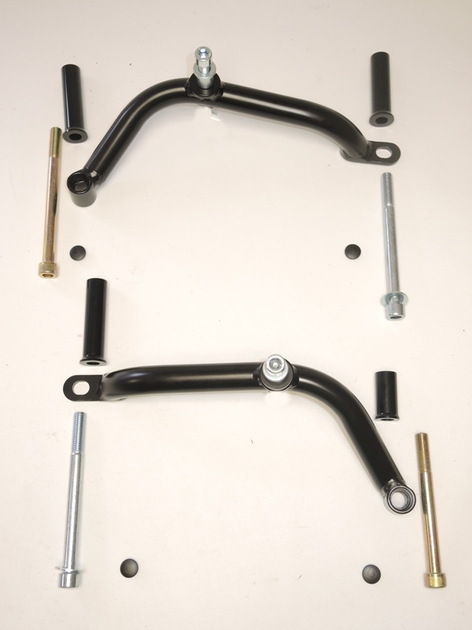
Left side
3
Obr.1
ID | Description | Cat.N | Qt
1 | Steel bar protector holder | 531 | 1
2 | Spacer 47,5mm front | 1179 | 1
3 | Spacer 82 mm rear | 1180 | 1
4 | Bolt M12x120x1,25 front | 913 | 1
5 | Bolt M12x140x1,25 rear | 995 | 1
6 | Washer M12 | 803 | 1
7 | Steel box | X1 | 1
8 | Bolt M10x50 | 849 | 1
9 | Plastic cover M12 | X60 | 2
2
8

7
1
5
4
9
9

6

Right side
3
1
2

7
4
8

5
6
9
9
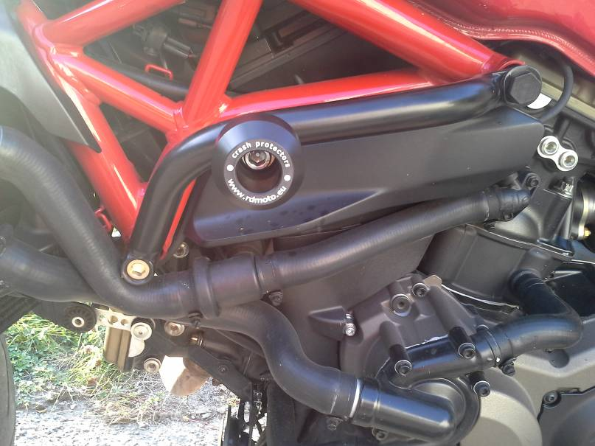
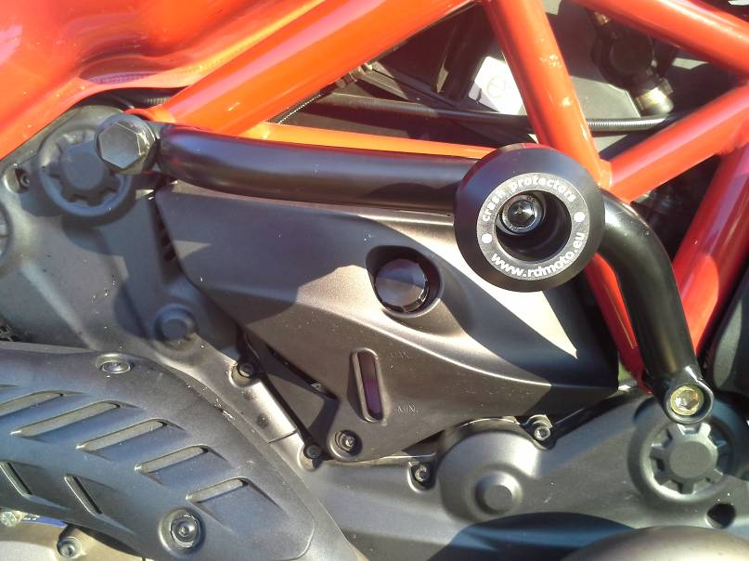

- Assembly place as you can see on the pictures.
- Dismantle original bolts M12 from left side.
- Place front and rear spacers into the frame. On the frame mounte steel holder for protector. Put washer on the rear bolt ID.5+ID.6.
- Place plastic cover into the bolts.
- Insert steel box ID.7 into protector, take bolt ID.8 and mount protector.
- Dismantle original bolts M12 from right side.
- Place front and rear spacers into the frame. On the frame mounte steel holder for protector. Put washer on the rear bolt ID.5+ID.6.
- Place plastic cover into the bolts.
- Insert steel box ID.7 into protector, take bolt ID.8 and mount protector

Warning – use a glue of all threads during assembly. Recommend medium strong (blue).

