F1S
CFMOTO 650GT

Kit for Left Side |  |  |  |  | Kit for Right Side
ID | Description | Cat.No | Pcs |  | ID | Description | Cat.No | Pcs
1 | Steel adapter | 760 | 1 |  | 1 | Steel adapter | 761 | 1
2 | Bolt M8x40mm | 828 | 1 |  | 2 | Bolt M8x35mm | 861 | 2
3 | Bolt M8x25mm | 831 | 2 |  | 3 | Bolt M8x25mm | 831 | 1
4 | Flat washer M8 | 802 | 3 |  | 4 | Flat washer M8 | 802 | 3
5 | Dural. sleeve l=6mm | 1346 | 1 |  | 5 | Dural. sleeve l=9mm | 1347 | 1
6 | Dural. adapter under the slider | 316 | 1 |  | 6 | Dural. sleeve under the slider | 316 | 1
7 | Bolt M6x25mm | 877 | 3 |  | 7 | Bolt M6x25mm | 877 | 3
8 | Bolt M4x12mm | 876 | 2 |  | 8 | Bolt M4x12mm | 876 | 2
9 | Bolt M10x30mm | 882 | 1 |  | 9 | Bolt M10x30mm | 882 | 1
10 | Spring washer M10 | 801 | 1 |  | 10 | Spring washer M10 | 801 | 1
11 | RDmoto sticker |  | 1 |  | 11 | RDmoto sticker |  | 1

We recommend using medium strength thread glue during assembly.
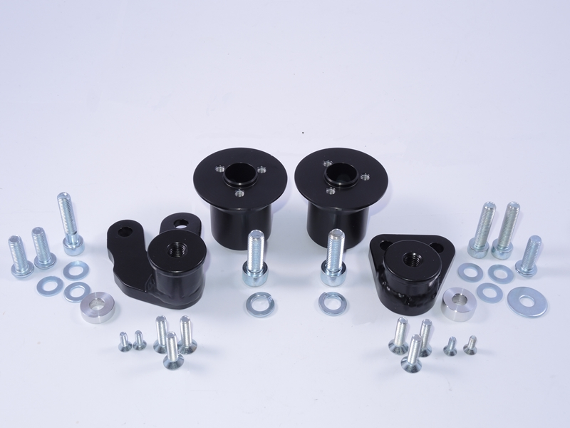
Left adapter ID.1
Right adapter ID.1
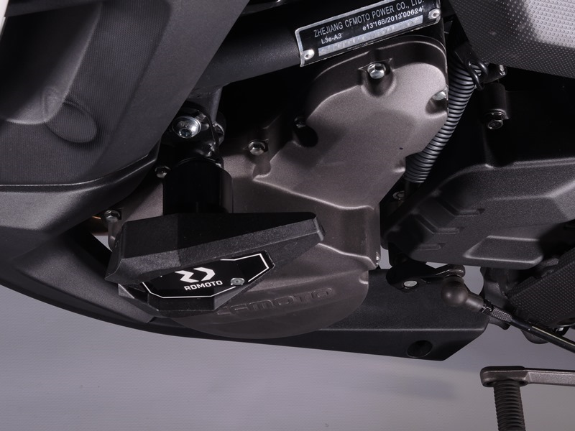
Adapter ID.1 + 2x bolt ID.3 + washer M8 ID.4 + bolt ID.2 + washer M8 ID.4 + dural. sleeve under the adapter ID.5
Slider + krytka + dural. adaptér pod slider ID.6 + šroub ID. 9 + podložka ID. 10 + 3x šroub ID.7 + 2x šroub ID.8
Slider + cap + dural. adapter under the slider ID.6 + bolt ID. 9 + washer ID. 10 + 3x bolt ID.7 + 2x bolt ID.8

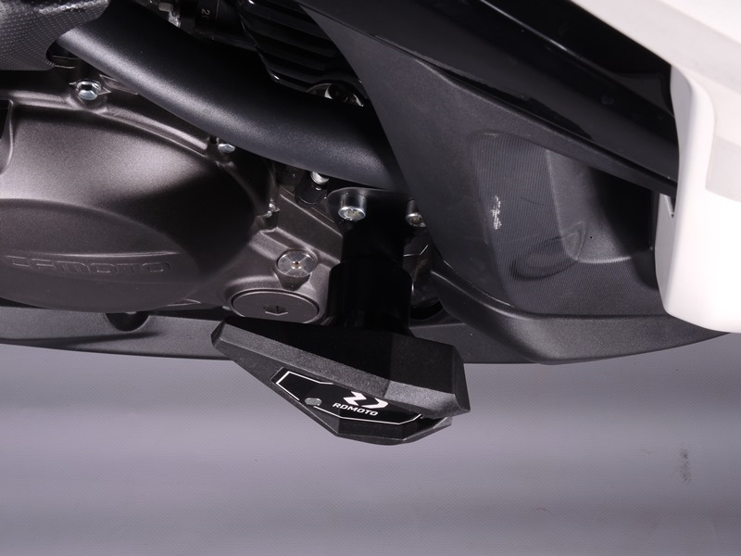
Slider + cap + dural. adapter under the slider ID.6 + bolt ID. 9 + washer ID. 10 + 3x bolt ID.7 + 2x bolt ID.8
Adapter ID.1 + bolt ID.3 + washer M8 ID.4 + 2x bolt ID.2 + washer M8 ID.4 + dural. sleeve under the adapter ID.5
9
13,11,12
10
Origin.bolt
Original bolt. Rear place.

