F1
CFMOTO 650GT

Mounting Kit – Left Side |  |  |  |  | Mounting Kit – Right Side
ID | Description | Cat.No | Pcs |  | ID | Description | Cat.No | Pcs
1 | Steel adapter | 760 | 1 |  | 1 | Steel adapter | 761 | 1
2 | Bolt M8x40mm | 828 | 1 |  | 2 | Bolt M8x35mm | 861 | 2
3 | Bolt M8x25mm | 831 | 1 |  | 3 | Flat washer M8 | 802 | 2
4 | Flat washer M8 | 802 | 2 |  | 4 | Dural. sleeve l=9mm | 1347 | 1
5 | Dural. sleeve length=6mm | 1346 | 1 |  | 5 | Dural. insert under protector | X1 | 1
6 | Dural. insert under protector | X1 | 1 |  | 6 | Dural. sleeve l=20mm | 2 | 1
7 | Dural. sleeve l=20mm | 2 | 1 |  | 7 | Bolt M10x60mm | 850 | 1
8 | Bolt M10x60mm | 850 | 1

Warning: We recommend using medium strength (blue) thread glue during assembly.

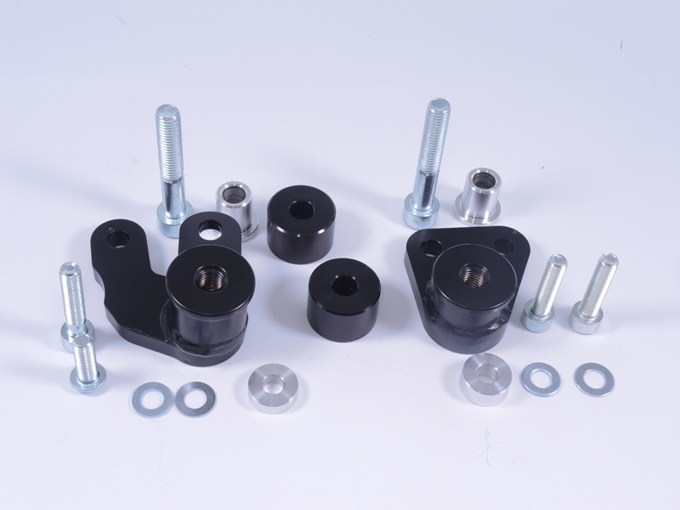
Left adapter ID.1
Right adapter ID.1
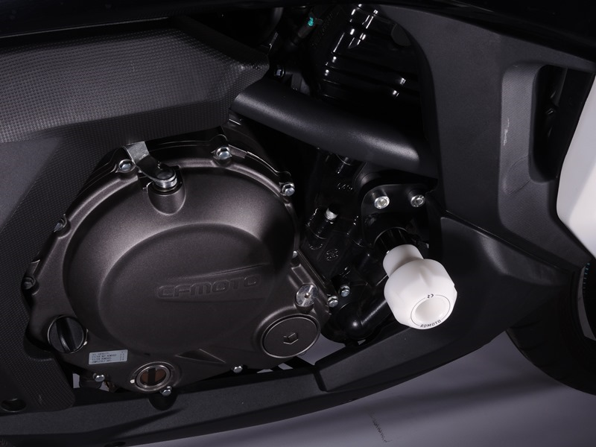
Steel adapter ID.1 + 2x bolt ID.2 + 2x washer M8 ID.3 + dural. sleeve under the adapter ID.4
Protector + dural.sleeve under the protector ID.6 + dural. insert into the protector ID.5 + bolt ID.7

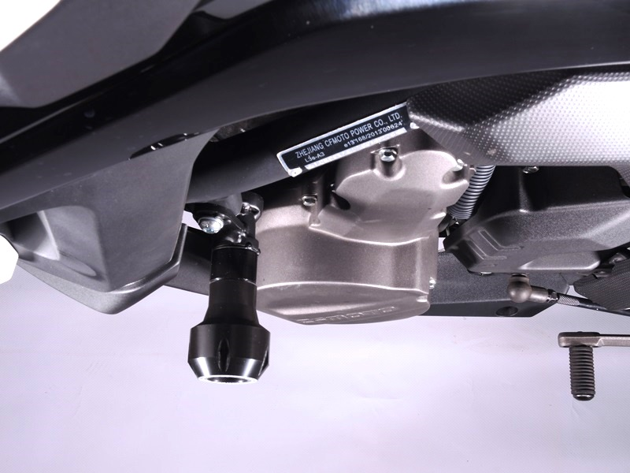
Protector + dural.sleeve under the protector ID.7 + dural. insert into the protector ID.6 + bolt ID.8
Steel adapter ID.1 + bolt ID.2 + bolt ID.3 + 2x washer M8 ID.4 + dural. sleeve under the adapter ID.5
9
13,11,12
10
Origin.bolt
Original bolt. Rear place.

