H10S
Honda CBR600RR 2003-2006

Kit for left side: |  |  |  |  | Kit for right side:
ID. | Description | Cat.N | Qt |  |  | ID. | Description | Cat.N | Qt
1 | Slider holder | 317 | 1 |  |  | 1 | Slider holder | 317 | 1
2 | Bolt M12x85x1,25mm | 902 | 1 |  |  | 2 | Bolt M12x85x1,25mm | 902 | 1
3 | Dural.cylinder d=30mm | 3 | 1 |  |  | 3 | Dural.cylinder d=30mm | 3 | 1
4 | Bolt M10x30mm | 882 | 1 |  |  | 4 | Bolt M10x30mm | 882 | 1
5 | Bolt M10x55mm | 1008 | 1 |  |  | 5 | Bolt M10x55mm | 1008 | 1
6 | Steel adapter | 510 | 1 |  |  | 6 | Steel adapter | 511 | 1
7 | Dural. cylinder d=16mm | 127 | 1 |  |  | 7 | Dural.cylinder d=11mm | 17 | 1
8 | Tape 3M |  | 1 |  |  | 8 | Tape 3M |  | 1
9 | Duralumin rod  AL16 (M10)x392x30x30 |  | 1 |  |  | 10 | Bolt M6x25 | 877 | 3
10 | Bolt M6x25 | 877 | 3 |  |  | 11 | Bolt M4x16 | 876 | 2
11 | Bolt M4x16 | 876 | 2

This fitting kit is without fairing modification.

Instruction to assembly:

- Take off left and right hand side fairng.
- Take off original bolt M12 from frame.
- 3M tape stick on the frame on the place wher moto frame is touching with steel adapter ID.6.
- Mounting steel adapters on the motorcycle ID.6, Right hand side adapter insert between the engine and frame. Don´t forget put dural. cylinder ID.7 between the adapter and frame.For thighten use bolt ID.2.
- For thighten on the left side use bolt ID.2. Don´t forget put dural. cylinder ID.7 between the adapter and frame.
- Put dural. rod ID.9 between the left and right adapters,this rod mounting by bolts ID.4
- Check all bolts and return back fairings on the bike.
- Into the slider holder ID.1 insert bolt ID.5, under the alu. slider holder put spacer ID.3.
- This kits is gripping on the steel adapters. Place slider ant mount it by bolts ID.10 and insert alu. cover, use bolts ID.11.

Warning: We recommend use the glue of all threads. Medium strong.

5
1
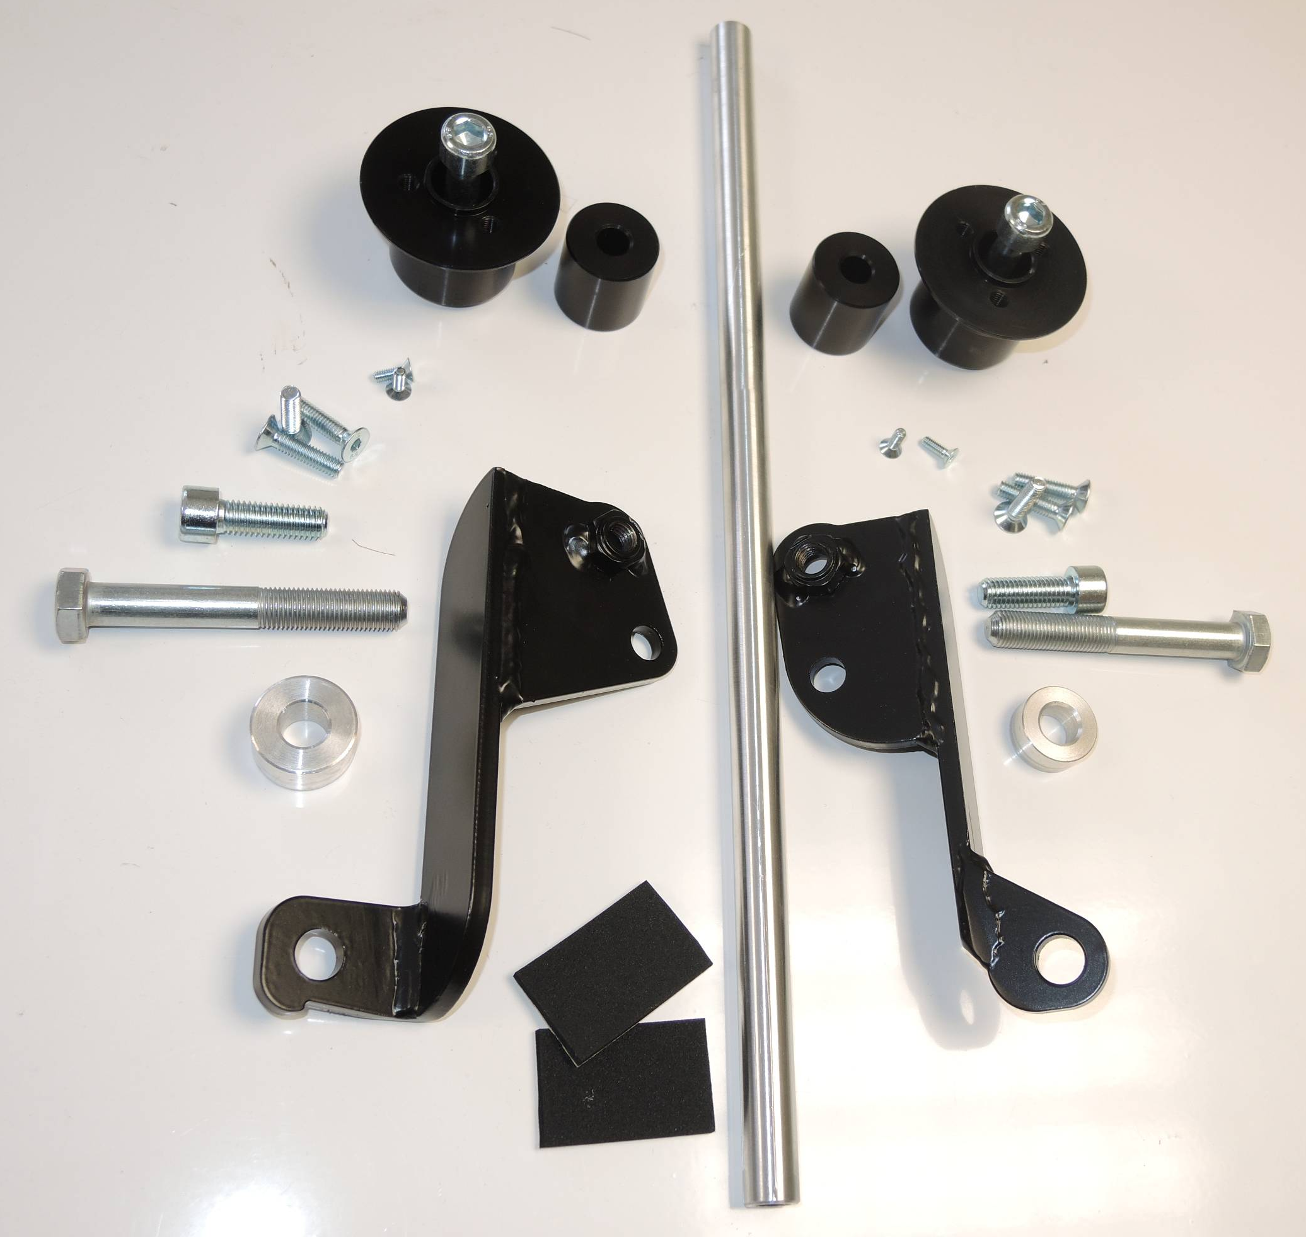
3
1
5
6
2
7
8
2
7
6
3
4
4
9
11
11
11
10

