H11
Honda CBR900 -´99

Fitting kit left side: Fitting kit right side:
ID | Description | Cat.N | Qty
1 | Steel box M10 | X1 | 1
2 | Bolt M10X90 | 880 | 1
3 | Dural.cylinder d=40 | 4 | 1
4 | Steel adapter | 518 | 1
5 | Bolt M10x60x1,25 | 896 | 1
6 | Washer M10 | 801 | 1
7 | Dural.cylinder d=18 | 1135 | 1
8 | 3M tape |  | 1
9 | AL bar AL16x392x30x30 |  | 1
ID | Description | Cat.N | Qty
1 | Steel box M10 | X1 | 1
2 | Bolt M10X90 | 880 | 1
3 | Dural.cylinder d=40 | 4 | 1
4 | Steel adapter | 517 | 1
5 | Bolt M10x60x1,25 | 896 | 1
6 | Washer M10 | 801 | 1
7 | Dural.cylinder d=8 | 1134 | 1
8 | 3M tape |  | 1

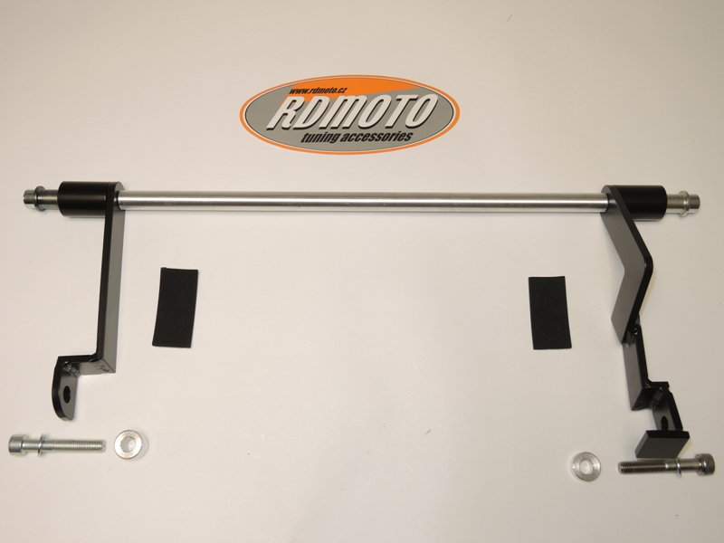

3
1
1
3

2
2

4
8
9
8
4
5

7
5
7

6
6

Instruction to assembly left side:
- Take out fairing.
- Dismantle bolt M10 from frame.
- Sticking 3M tape ID.4 on the steel adapter, where it is touching with frame.
- Insert dural.cylinder ID.7 into the frame. Take bolt ID.5 and washer ID.6 and mount steel adapter on frame.
- Through the bike insert AL rod ID.9.
- Into the protector insert steel box ID.1 and bolt ID.2. Under the protector insert dural.cylinder ID.3.
- This set grip into AL. rod.

Instruction to assembly right side:
- Take out fairing.
- Dismantle bolt M10 from frame.
- Sticking 3M tape ID.4 on the steel adapter, where it is touching with frame.
- Insert dural.cylinder ID.7 into the frame. Take bolt ID.5 and washer ID.6 and mount steel adapter on frame.
- Into the protector insert steel box ID.1 and bolt ID.2. Under the protector insert dural.cylinder ID.3.
- This set grip into AL. rod.

Warning: We recommend use the glue of all threads. Medium strong.

