H12SD
Honda CBR929/954RR 2000-2003

Kit for the left side |  |  |  |  | Kit for the right side
ID. | Description | Cat.No | Pcs |  |  | ID. | Description | Cat.No | Pcs
1 | SLD adapter | 537 | 1 |  |  | 1 | SLD adapter | 537 | 1
2 | Bolt M10x110x1,25mm | 928 | 1 |  |  | 2 | Bolt M10x110x1,25mm | 928 | 1
3 | Dural. cylinder 32mm | 54 | 1 |  |  | 3 | Dural. cylinder 23mm | 53 | 1
4 | Dural. cylinder 20mm | 10 | 1 |  |  | 4 | Dural. cylinder 20mm | 10 | 1
5 | Washer M10 (spring) | 801 | 1 |  |  | 5 | Washer M10 (spring) | 801 | 1
6 | Bolt M8x25 | 815 | 2 |  |  | 6 | Bolt M8x25 | 815 | 2
7 | Washer M8 | 800 | 2 |  |  | 7 | Washer M8 | 800 | 2
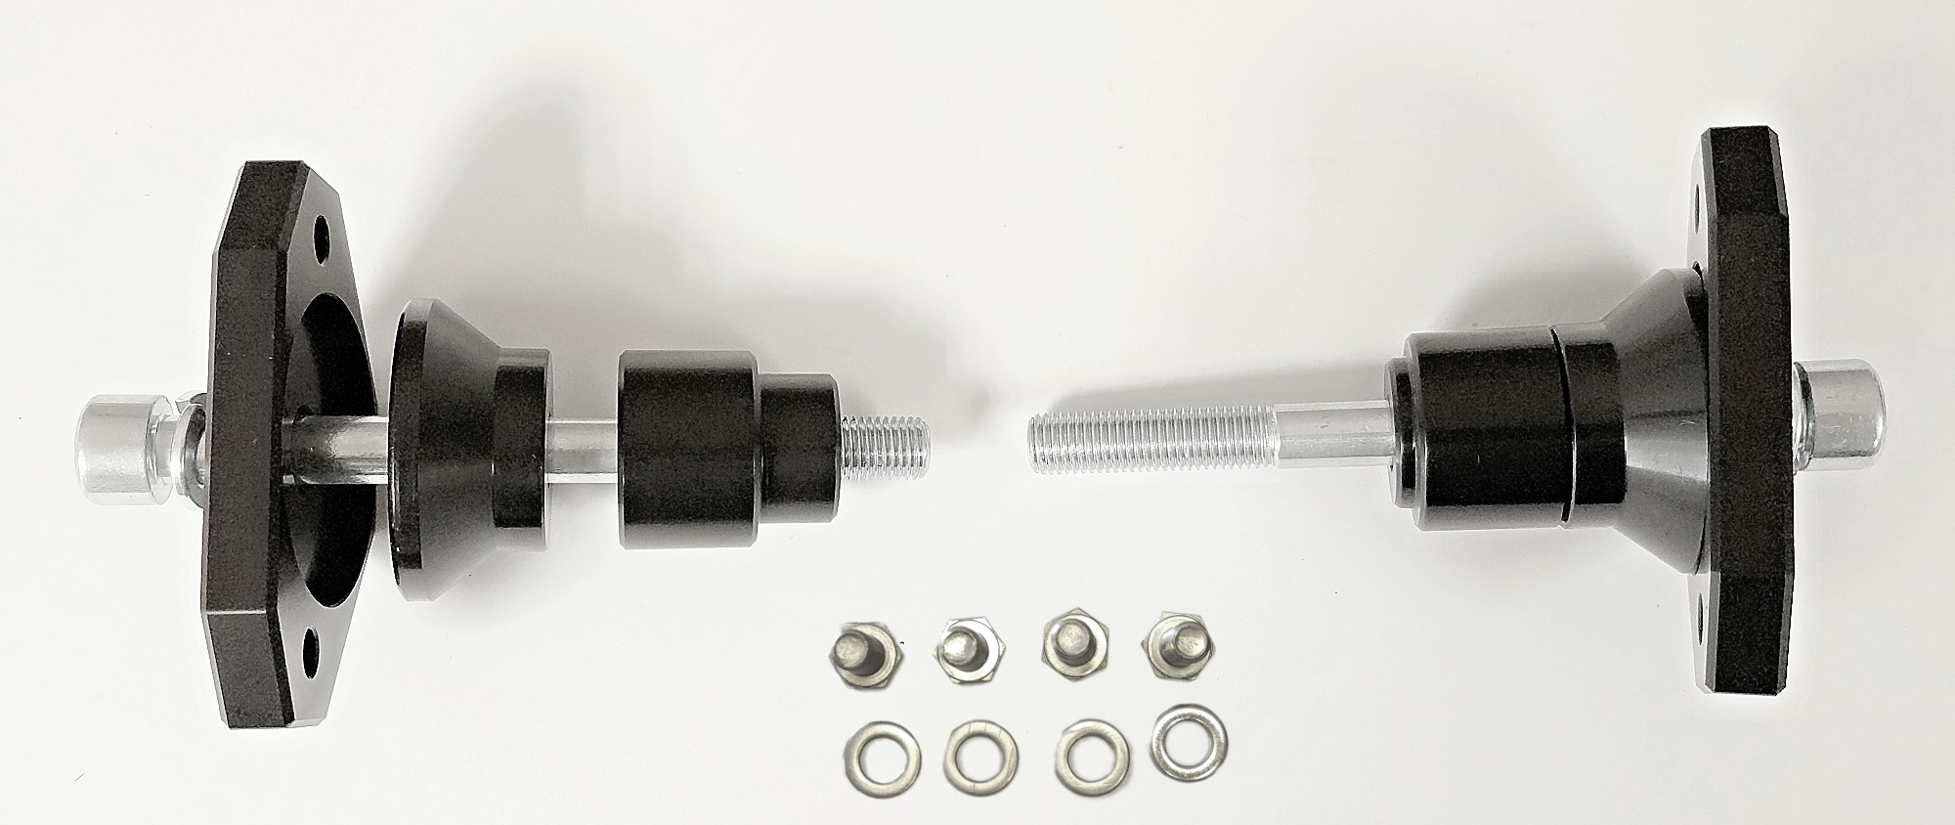
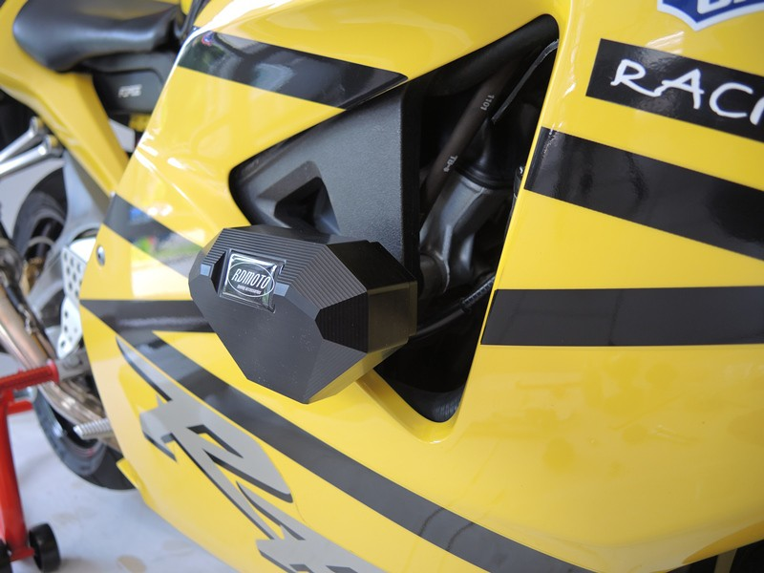
Instructions

- Dismantle original bolt from the frame of motorcycle.
- Prepare bolt ID2 and put washer ID5, SLD adapter ID1, dural cylinder ID4 and dural cylinder ID3 on it.
- Fit this kit on the motorcycle.
- Fit slider using two bolts ID6 and washers ID7.

