H12S
Honda CBR929/954RR 2000-2003

Kit for the left side |  |  |  |  | Kit for the right side
ID. | Description | Cat.no | Pcs |  |  | ID | Description | Cat.no. | Pcs
1 | slider RDmoto | SL | 1 |  |  | 1 | slider RDmoto | SL | 1
2 | Cover | SLcap.. | 1 |  |  | 2 | Cover | SLcap.. | 1
3 | Moto adapter | DV-310 | 1 |  |  | 3 | Moto adapter | DV-309 | 1
4 | Bolt M6x25 | 877 | 3 |  |  | 4 | Bolt M6x25 | 877 | 3
5 | Bolt M4x16 | 876 | 2 |  |  | 5 | Bolt M4x16 | 876 | 2
6 | Bolt M10x70x1,25mm | 898 | 1 |  |  | 6 | Bolt M10x70x1,25mm | 898 | 1

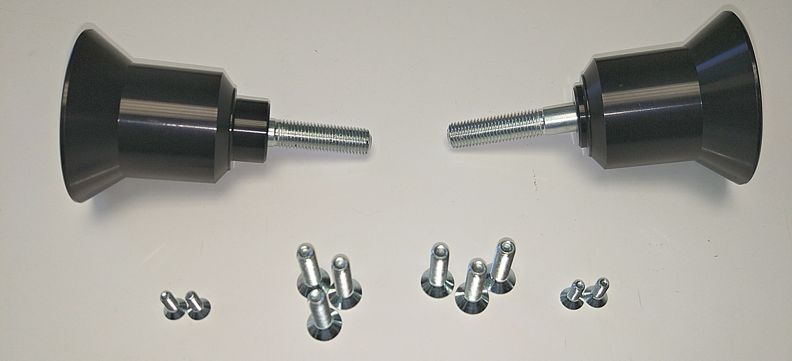

Instructions:

- Remove original bolt from the frame of motorcycle.
- Using bolt M10 (ID6) fit dural adapter (ID3). Set rotation before tightening.
- Place slider (ID1) on the dural adapter and tighten it using bolts (ID4)
- Place cover (ID2) into the slider and tighten it using botls (ID5).

We recommend to use the safety glue on all threads (medium strong).

Illustrative photos

