H13SD
Honda CBR125R 2004-2010

Fitting kit for left side: |  |  |  |  | Fitting kit for right side:
Note | Description | No. part | Quant. |  |  | Note | Description | No. part | Quant.
1 | Steel adapter- black | 507 | 1 |  |  | 1 | Steel adapter- black | 506 | 1
2 | Alluminium cylinder d= 77 | 481 | 1 |  |  | 2 | alluminum cylinder d=82mm | 482 | 1
3 | bolt M8x25mm | 831 | 2 |  |  | 3 | bolt M8x25mm | 831 | 2
4 | Steel rod M8x288x15x15 | - | 1 |  |  | - | - | - | -
5 | Nut M8 (locking) | 809 | 1 |  |  | 5 | nut M8 (locking) | 809 | 1
6 | washer (flat) | 802 | 1 |  |  | 6 | washer (flat) | 802 | 1
7 | Plastic cover M8 | X46 | 1 |  |  | 7 | Plastic cover M8 | X46 | 1

Mounting kit for SLD:

8 | Slider | SLD | 2
9 | Aluminium adapter | 13 | 2
10 | Aluminium holder | 537 | 2
11 | botl M10x75 | 1007 | 2
12 | washer M10 | 804 | 2
13 | nut M10 (locker) | 810 | 2
14 | bolt M8x25 | 815 | 4
15 | Washer M8 | 800 | 4

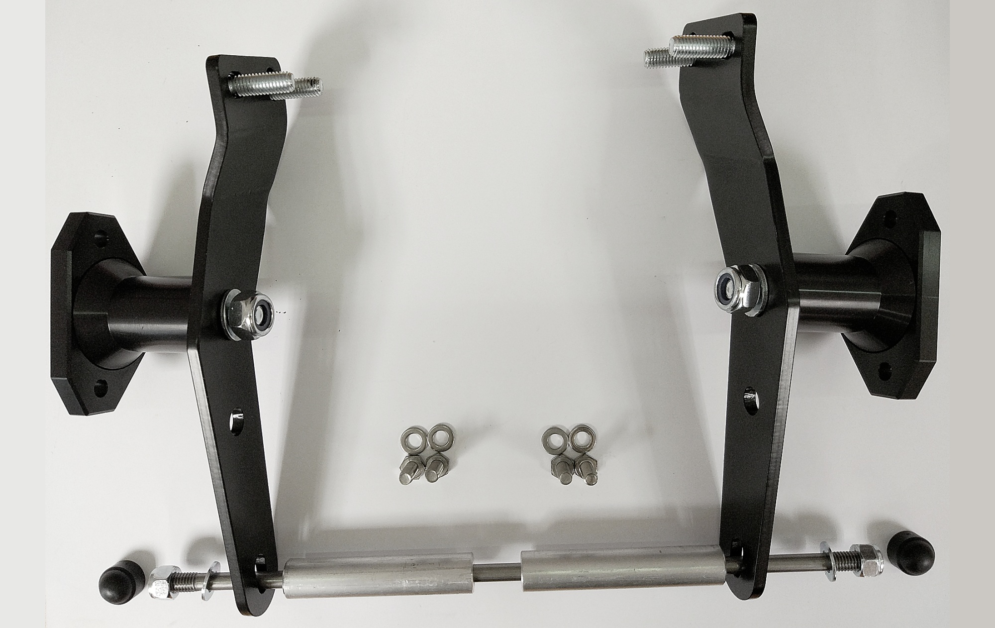

Warning - the threads of the screws is recommended to use glue medium weight (blue color).

After the overthrow of the whole set, we check all connections.

Mounting – left side :

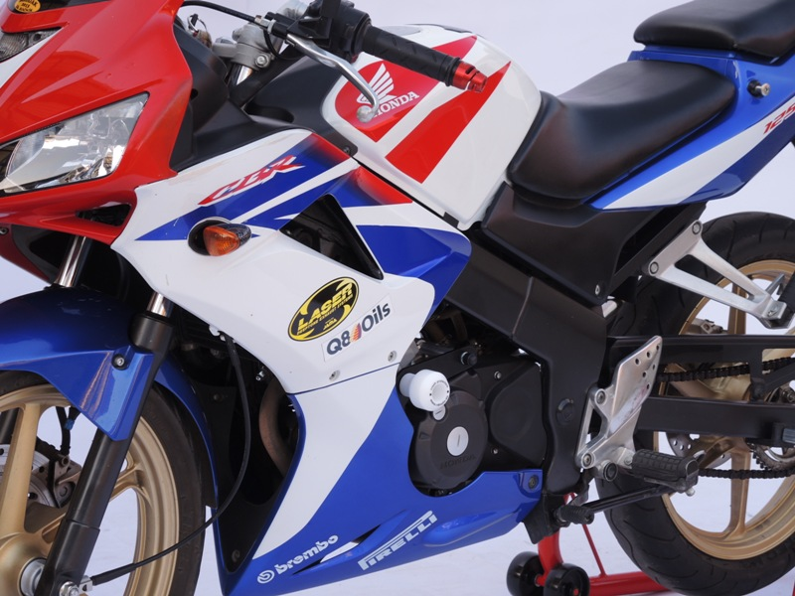
- Take off plastick fairing (left and right side) .

- Dismantle of original bolts from frame.
- Put on steel adapter (note 1), which is mounted by a screws (note.3) on the frame.
- Put on alluminium cylinder d= 77mm (note 2).
- Insert steel rod M8 (note 4) through the adapter,aluminium cylinder and engine.
- Steel rod M8 tighten to adapter by washer (note 6) and nut (note 5).
- Put on plastic cover (note 7).

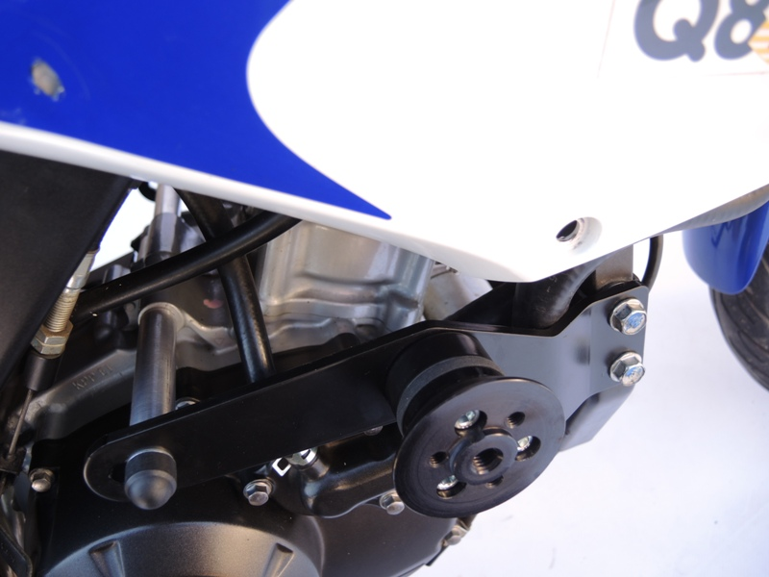
(only illustrative photo)
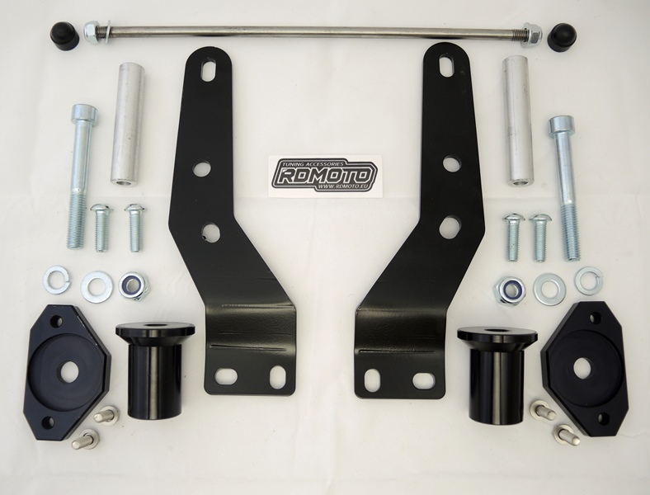
Mounting protectors:

- Put on the adapter (note 9) fit aluminium holder (note 10)by bolt M10 (note11), washer (note 12) and nut (note 13) and mounting on the adapter.
- On the slider holder fitting slider (note 8) by M6 screw (note 14).

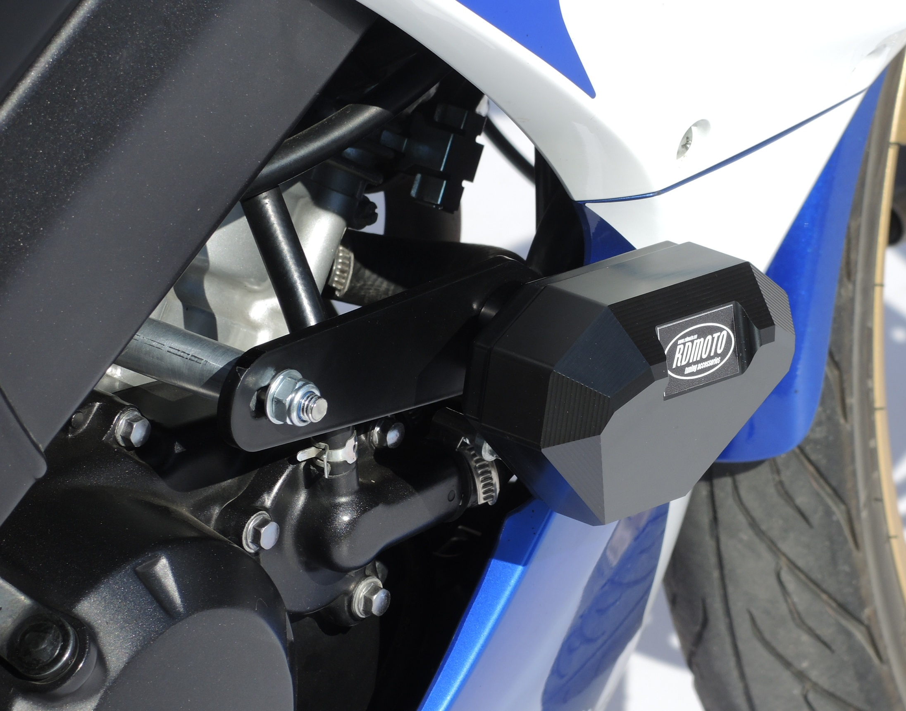

Mounting kit for right side:
(Almost the same as left side.)

- Dismantle of original bolts from frame.
- Put on steel adapter (note 1), which is mounted by a screws (note.3) on the frame.
- Put on alluminium cylinder d= 77mm (note 2).
- Insert aluminium cylinder d= 82mm (note 2) on the steel rod.
- Steel rod M8 tighten to adapter by washer (note 6) and nut (note 5).
- Put on plastic cover (note 7).

Mounting protectors:

- Put on the adapter (note 9) fit aluminium holder (note 10)by bolt M10 (note11), washer (note 12) and nut (note 13) and mounting on the adapter.
On the slider holder fitting slider (note 8) by M6 screw (note 14)

On the bike put on fairing.

Warning - the threads of the screws is recommended to use glue medium weight (blue color).

After the overthrow of the whole set, we check all connections.

