H13S
Honda CBR125R 2004-2010
Fitting kit for left side: |  |  |  |  | Fitting kit for right side:
Note | Description | No. part | Quant. |  |  | Note | Description | No. part | Quant.
1 | Steel adapter- black | 507 | 1 |  |  | 1 | Steel adapter- black | 506 | 1
2 | Alluminium cylinder d= 77 | 481 | 1 |  |  | 2 | alluminum cylinder d=82mm | 482 | 1
3 | bolt M8x25mm | 831 | 2 |  |  | 3 | bolt M8x25mm | 831 | 2
4 | Steel rod M8x288x15x15 | - | 1 |  |  | - | - | - | -
5 | Nut M8 (locking) | 809 | 1 |  |  | 5 | nut M8 (locking) | 809 | 1
6 | washer (flat) | 802 | 1 |  |  | 6 | washer (flat) | 802 | 1
7 | Plastic cover M8 | X46 | 1 |  |  | 7 | Plastic cover M8 | X46 | 1

Mounting kit for SL01:

8 | Slider RDmoto | SL | 2
9 | Color cover | SLcap. | 2
10 | Alluminium adapter for slider d=40mm | DV 317 | 2
11 | Bolt M10x30 | 882 | 2
12 | Washer M10 | 804 | 2
13 | Nuts M10 (locking) | 810 | 2
14 | Bolt M6x25 | 877 | 6
15 | Bolts M4x16 | 876 | 4
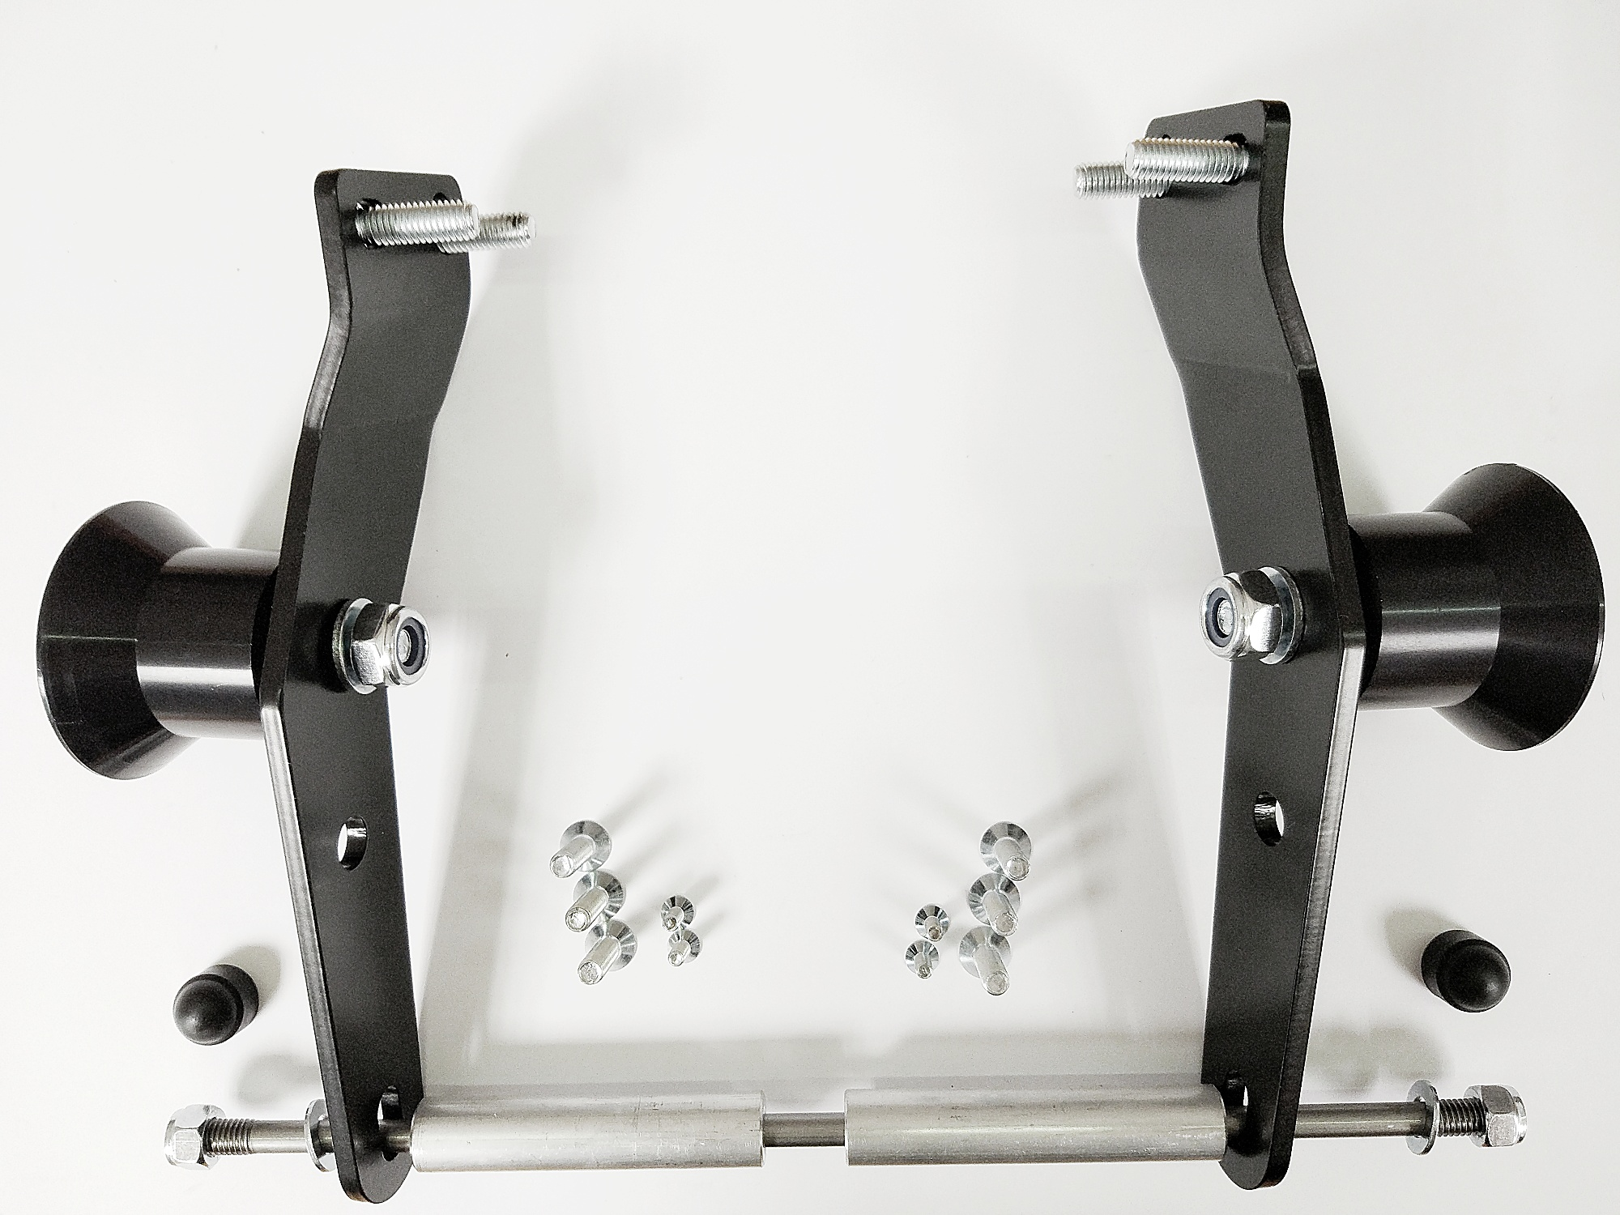

Warning - the threads of the screws is recommended to use glue medium weight (blue color).

After the overthrow of the whole set, we check all connections.

Mounting – left side :

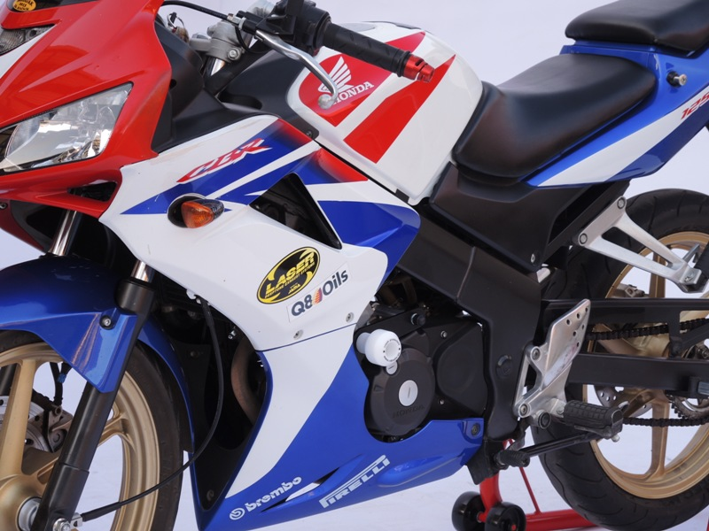
- Take off plastick fairing (left and right side) .

- Dismantle of original bolts from frame.
- Put on steel adapter (note 1), which is mounted by a screws (note.3) on the frame.
- Put on alluminium cylinder 77mm (note 2).
- Insert steel rod M8 (note 4) through the adapter,aluminium cylinder and engine.
- Steel rod M8 tighten to adapter by washer (note 6) and nut (note 5).
- Put on plastic cover (note 7).

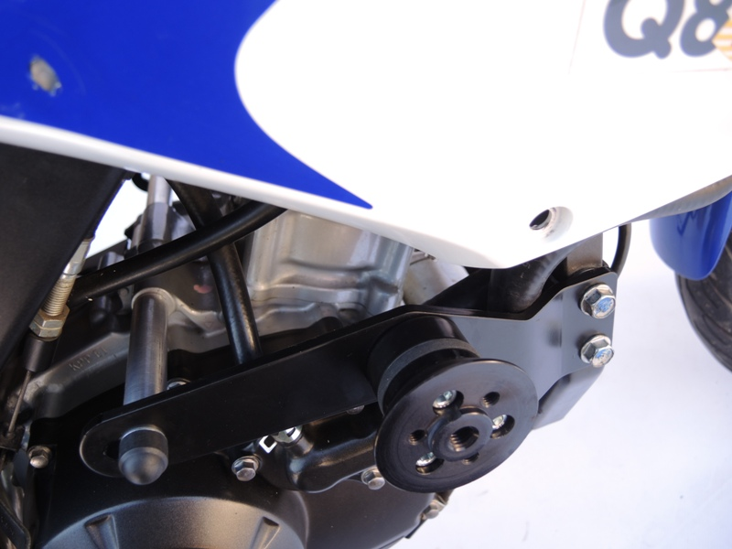
Mounting crash protectors:
- Mounting slider adapter (note 10) by bolt M10 (note 11), washer (note12) and nut (note 13).
- You can petting angel of slider.
- Fixed bolt M10 (note 11).
- Put on the adapter is mounting slider (note 8) by bolt M6 (note 14).
- Put on the slider color cover (note 9) by bolts (note 15).

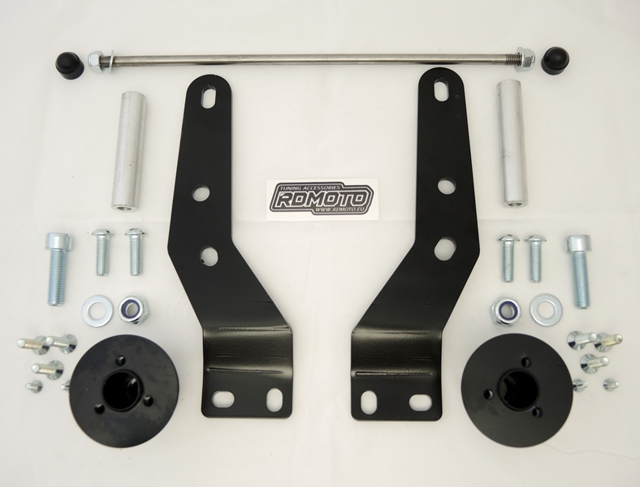

Mounting kit for right side:
(Almost the same as left side.)

- Dismantle of original bolts from frame.
- Put on steel adapter (note 1), which is mounted by a screws (note.3) on the frame.
- Put on alluminium cylinder 77mm (note 2).
- Insert aluminium cylinder 82mm (note 2) on the steel rod.
- Steel rod M8 tighten to adapter by washer (note 6) and nut (note 5).
- Put on plastic cover (note 7).

Mounting crash protectors:
- Mounting slider adapter (note 10) by bolt M10 (note 11), washer (note12) and nut (note 13).
- You can petting angel of slider.
- Fixed bolt M10 (note 11).
- Put on the adapter is mounting slider (note 8) by bolt M6 (note 14).
- Put on the slider color cover (note 9) by bolts (note 15).

On the bike put on fairing.

Warning - the threads of the screws is recommended to use glue medium weight (blue color).

After the overthrow of the whole set, we check all connections.

