H13
Honda CBR125R 2004-2010

Fitting kit for left side: |  |  |  |  | Fitting kit for right side:
Note | Description | No. part | Quant. |  |  | Note | Description | No. part | Quant.
1 | Steel adapter- black | 507 | 1 |  |  | 1 | Steel adapter- black | 506 | 1
2 | Alluminium cylinder d= 77 | 481 | 1 |  |  | 2 | alluminum cylinder d=82mm | 482 | 1
3 | bolt M8x25mm | 831 | 2 |  |  | 3 | bolt M8x25mm | 831 | 2
4 | Steel rod M8 | 8x288x15x15 | 1 |  |  | 4 | -------------------------- | --- | --
5 | Nut M8 (locking) | 809 | 1 |  |  | 5 | nut M8 (locking) | 809 | 1
6 | washer (flat) | 802 | 1 |  |  | 6 | washer (flat) | 802 | 1
7 | Plastic cover M8 | X46 | 1 |  |  | 7 | Plastic cover M8 | X46 | 1

Crash protectors:

Note | Description |  | No. part | Quant.
8 | Crash protectors |  |  | 2
9 | Steel sleeve |  | X1 | 2
10 | bolt M10x55mm |  | 1002 | 2
11 | washer (flat) |  | 804 | 2
12 | nut (locker) |  | 810 | 2
13 |  | Aluminium adapter d= 15mm | DV8 | 2

Mounting kit:

Mounting kit for PH01, PHV1, PHV2:
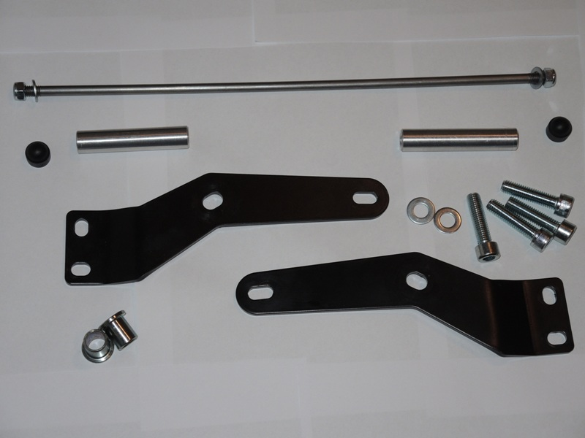

Warning - the threads of the screws is recommended to use glue medium weight (blue color).

After the overthrow of the whole set,check all connections.

Mounting – left side :

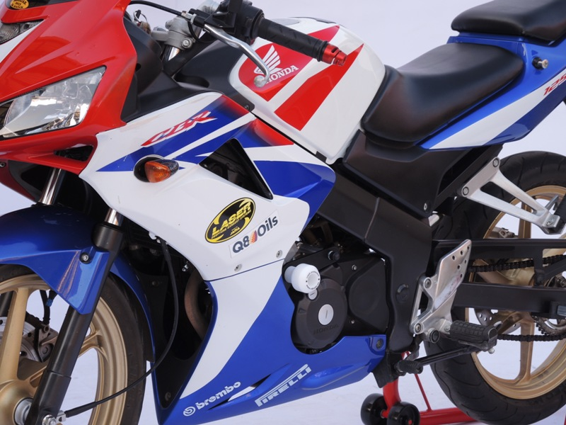
- Take off plastick fairing (left and right side) .

- Dismantle of original bolts from frame.
- Put on steel adapter (note 1), which is mounted by a screws (note.3) on the frame.
- Put on alluminium cylinder d= 77mm (note 2).
- Insert steel rod M8 (note 4) through the adapter,aluminium cylinder and engine.
- Steel rod M8 tighten to adapter by washer (note 6) and nut (note 5).
- Put on plastic cover (note 7).

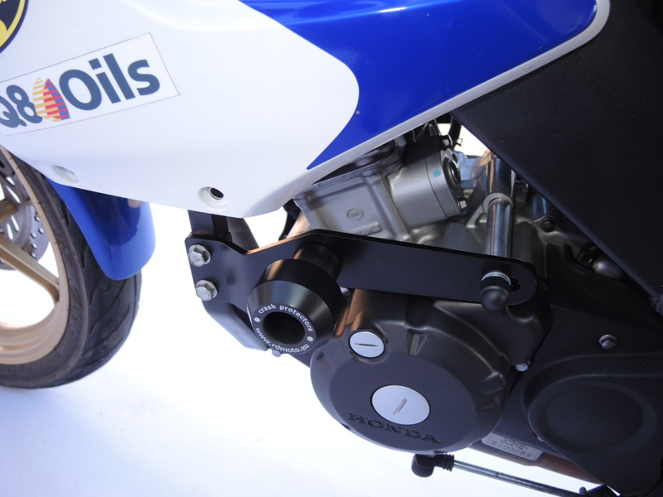
Mounting crash protectors:

- Inside to the crash protectors insert steel sleeve (note 9)
- Between the adapter and protector put on alluminium reduction d= 15mm (note 13).
- This set fixed by bolt, washer (note.11) and nut (note.12)
- Crash protectors PHV1, PHV2 take on colour cover.

Mounting kit for right side:
(Almost the same as left side.)

- Dismantle of original bolts from frame.
- Put on steel adapter (note 1), which is mounted by a screws (note.3) on the frame.
- Put on alluminium cylinder d= 77mm (note 2).
- Insert aluminium cylinder d= 82mm (note 2) on the steel rod.
- Steel rod M8 tighten to adapter by washer (note 6) and nut (note 5).
- Put on plastic cover (note 7).

Mounting crash protectors:

- Inside to the crash protectors insert steel sleeve (note 9)
- Between the adapter and protector put on alluminium reduction d= 15mm (note 13).
- This set fixed by bolt, washer (note.11) and nut (note.12)
Crash protectors PHV1, PHV2 take on colour cover

On the bike put on fairing.

Warning - the threads of the screws is recommended to use glue medium weight (blue color).

After the overthrow of the whole set, we check all connections.

